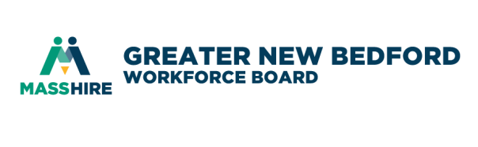
MassHire Greater New Bedford Workforce Board

Performance and Oversight Committee
May 7, 2019 8:00 a.m.
Quest Center for Innovation

AGENDA (revised 4/30/19 to include meeting schedule)

- Call to Order
- Minutes of last meeting
- MassHire Department of Career Services sent us a letter on March 21, 2019 confirming the approval of our FY19 WIOA Local Annual Operating Plan - Jim
- Field Management & Oversight Annual Fiscal Systems Review-Fiscal Year 2019 that ran from February 4, 2019 through February 8, 2019 - extended for staff training - Donna
- Data and performance reporting MHGNBCC – James/Elizete
- Update on three audits - Julie
- TWP audit update - Julie
- Update on Budget - Julie
- Other Business
  - Committee input
  - Staff input
  - Future Meetings @ Quest Center – if in agreement, save-the-dates on your calendars – agenda will be attached to the actual meeting invite
    - Tuesday May 7
    - Tuesday June 4
    - Tuesday July 9
    - Tuesday August 6
    - Wednesday September 4
    - Tuesday October 1
    - Tuesday November 5
- Adjourn

New Bedford Workforce Board

Performance and Oversight Committee
September 18, 2018 8 a.m.
1213 Purchase Street, New Bedford, MA | 2nd Floor Conference Room

MINUTES
In attendance: R. Melbourne, P. Correia, M. Tavares
Absent: J. Fernandes
Staff in attendance: K. Holloway Cripps, J. Rodriques
Others in attendance: E. Perry, J. Daniels, A. Vandiver

Call to Order
R. Melbourne called the meeting to order at 8:05 a.m.
Consent Agenda (Vote)
R. Melbourne made a motion to accept the meeting minutes of August 14, 2018. P. Correia seconded. All in favor, no abstentions nor nays.
Introduce new FAM
J. Rodriques introduced to committee.

Data and Performance reporting
R. Melbourne opened the discussion with the committee and career center staff about the types of data the board and committees would like to see. A discussion ensued about MOSES, OSCARR, Crystal and other reports that are generated through DCS and the Career Centers.
P. Correia asked about integration of the systems with commonly used job seeking systems leveraged by businesses and job seekers, such as Indeed. A discussion ensued about JobQuest functionality.
P. Correia referenced the certification standards and stated they committee should use these as a standard for reports. A discussion ensued.
The committee discussed what types of data can be generated, and the types they may like to see.
The committee will consider the types of questions they want answered by the career center on a regular basis for reporting such as the standards for certification.
The committee agreed to reconvene in October with the staff to solidify the data reporting.

Other Business
No other business.

Adjourn
The meeting adjourned at 09:20 a.m.

