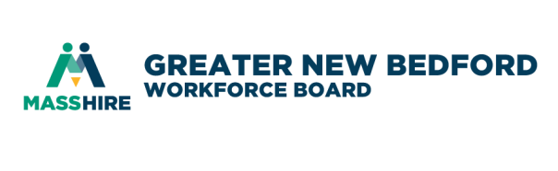
MassHire Greater New Bedford Workforce Board

Performance and Oversight Committee
October 2, 2019 8:00 a.m.
Quest Center for Innovation

AGENDA

- Call to order

- Vote on minutes of the September 4th meeting – attached

- Continue with the a deep dive of FY20 Goals & Objectives
  - CC reports
  - Needs of the Committee
  - BSU review
  - CC survey update

- Future Meetings @ Quest Center – if in agreement, save-the-dates on your calendars – agenda will be attached to the actual meeting invite if available
Wednesday November 6 @ Quest Center
Wednesday December 4 @ Quest Center
- Adjourn

Performance and Oversight Committee

Minutes of September 4, 2019

In attendance: Members - P. Correia, R. Melbourne

Absent: M. Tavares, J. Fernandes
Staff: D. J. Ramos, D. Meggison

Meeting called to order by Chair Ron Melbourne at 8:05

Vote on minutes of the August 6, 2019 meeting – attached. P. Correia made the motion to approve and R. Melbourne seconded the motion.

Using the FY20 Goals & Objectives document that was distributed previously, the members present discussed whether or not to modify the form at all or add to it in any way. D. Ramos reiterated that this wasn’t necessarily the content to be used and that the committee members need to direct the goal and objectives for themselves with assistance from the WDB staff. Additional goals/objectives can be established be reviewing what objective were not met in previous years and focusing on them. Additionally we had the Assurances from the FY2020 Local Operating Plan as well the TEGL 10-16 from the Department of Labor.

Paul Correia stated we should use the document to ‘drive the meeting’ each month. In order to do that we should distribute the Career Center reports and financials from the CFO prior to the meeting each month with enough time for review. The staff present agreed to implement that moving forward. Ron Melbourne would like the look at the Career Center reports and focus on what is ‘important to us as a Board’ and ‘get into the weeds on that’.

Other Business
- Staff has been asked to look into what kinds of surveys are being conducted at Mass Hire to see how job seekers and employers view the performance of the Career Center.

Future Meetings @ Quest Center – if in agreement, save-the-dates on your calendars – agenda will be attached to the actual meeting invite if available.

Wednesday October 2 @ Quest Center
Wednesday November 6 @ Quest Center
Wednesday December 4 @ Quest Center

Meeting adjourned at 8:59

