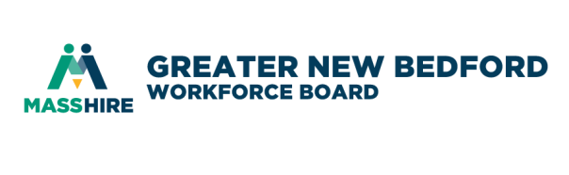
MassHire Greater New Bedford Workforce Board

Performance and Oversight Committee
September 4, 2019 8:00 a.m.
Quest Center for Innovation

AGENDA

- Call to order

- Vote on minutes of the August 6th meeting – attached

- Committee to strategize on FY20 Goals & Objectives

- Future Meetings @ Quest Center – if in agreement, save-the-dates on your calendars – agenda will be attached to the actual meeting invite if available
Wednesday October 2 @ Quest Center
Wednesday November 6 @ Quest Center
Wednesday December 4 @ Quest Center
- Adjourn

