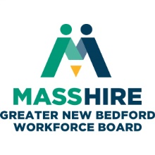
MassHire Greater New Bedford Workforce Board

Executive Committee
December 4, 2018 3:30 p.m.
Moby Dick Conference Room, New Bedford, MA

AGENDA

- Greeting and Call to Order
- Announcements
- Consent Agenda (Vote)
  - Minutes of September 20, 2018
  - Treasurer’s Report
- Reports
  - Executive Director
  - Committees
  - Career Center
- Fiscal Sponsorship (3:45 p.m.) (Vote)
- Budget
- Standard Operating Procedures (Vote)
- Policies (Vote)
  - WIOA Policies
    - Support Services
    - 14.000 ITA and Training Pro (amendment update)
    - 23.105.02 RESEA (amendment update)
    - 04.105 Four Year Local Plan
    - 31.100 Branding
    - 03.107 Conflict of Interest
    - 08.116 Priority of Services
- Local Plan (Extension) (Vote)
- Youth RFP Issuance (Vote TBD)
- Adjourn

