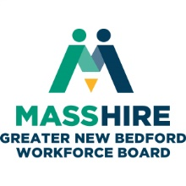
MassHire Greater New Bedford Workforce Board

Executive Committee
Thursday, January 3, 2019 noon
Quest Center 2nd floor conference room (large room in middle)

AGENDA

- Greeting and Call to Order
- Announcements
- Consent Agenda (Vote)
  - Minutes of December 4, 2018
  - Treasurer’s Report
- Reports
  - Executive Director
  - Committees
  - Career Center
- Fiscal Sponsorship Update
- Standard Operating Procedures (Vote)
- Policies (Vote)
  - WIOA Policies
    - 19.104 Requires Additional Assistance (Update)
    - Support Services (Update)
- Local Plan Update
- Board of Directors meeting
- Executive Session
- Adjourn

