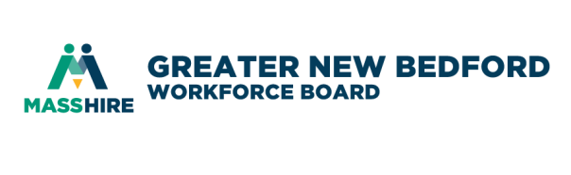
MassHire Greater New Bedford Workforce Board

Youth Committee
September 12, 2018 9:30 a.m.
Quest Center for Innovation | 1213 Purchase Street, NB MA 02740 2nd floor conference room

AGENDA

- Call to Order
- Workforce board staffing for youth programs
- Youth RFPs (Vote)
- FY19 Youth Strategic Planning for Committee
- Connecting Activities Update
- Other Business
- Adjourn

