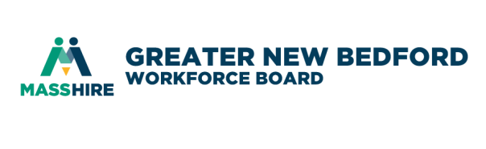
MassHire Greater New Bedford Workforce Board

Youth Committee
December 5, 2018 9:30 a.m.
Quest Center for Innovation | 1213 Purchase Street, NB MA 02740 2nd floor conference room

In attendance: J. Pelletier, C. Wallquist Absent: L. Orleans, D. Lima, H. Kennedy, J. O’Brien,
Others in attendance: T. Xavier, B. Alves, K. Lazaro
Staff in attendance: K. Holloway Cripps, J. Rodriques, A. McLaughlin

AGENDA
Call to Order
J. Pelletier called the meeting to order at 9:40 a.m.
No quorum.

Welcome to new workforce board staffer
All welcomed Andrea McLaughlin to the workforce board.

Youth RFPs (Vote)
No vote, discussed vote for potential funding at executive committee and noticed the workforce board is discussing available funding by reviewing current contracts.

FY19 Youth Strategic Planning for Committee
J. Pelletier discussed his goals for the committee including in the new year outlining key goals, discussing wins that could be achieved and supportive partners, making new connections, and aligning with regional groups. K. Holloway Cripps will send out a Doodle poll for late January for a two hour strategic planning breakfast meeting of the committee.

Connecting Activities Update
B. Alves and K. Lazaro gave an overview of the work to date with the ten schools in the region including job tours.

Career Center Update
T. Xavier gave an update of work with vendors to date and noted they are working on new processes.

Policy Update
K. Holloway Cripps shared that Andrea was reviewing policies and would be presenting to the executive committee a recommendation on the “requires additional barrier” for youth in January.

Other Business
n/a

Adjourn
The meeting adjourned at 10:35 a.m.

