GREATER NEW BEDFORD WORKFORCE AREA FOUR YEAR LOCAL PLAN

THE 2019-2022
FOUR YEAR LOCAL PLAN FOR THE
MassHire GREATER NEW BEDFORD WORKFORCE BOARD

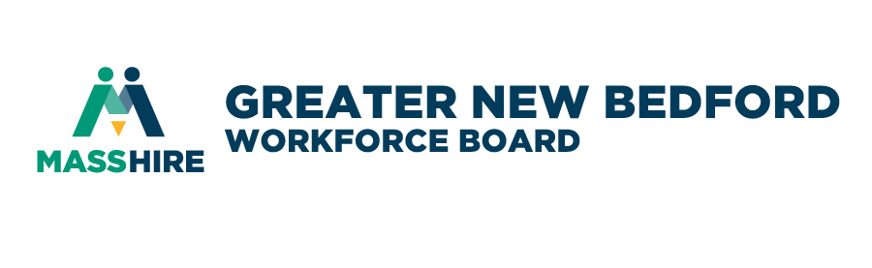
This is a publication of the Greater New Bedford Workforce Investment Board, Inc. dba MassHire Greater New Bedford Workforce Board to meet the requirements as established in Massachusetts Workforce Issuance 100 DCS 04.105. All information is to the best of the workforce board’s knowledge factual and true but shall be held harmless for any information deemed false inadvertently. This work shall be for representative purposes only. This publication allows for redistribution, commercial and non-commercial, as long as it is passed along unchanged and in whole, with credit to the workforce board. Any copyrighted materials utilized herein are the express property of the holder and this work does not seek to capitalize from its use.
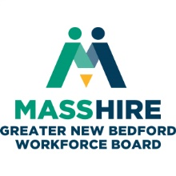
FOUR YEAR LOCAL PLAN
(Cycle 2 2019-2022)
For Inquires please contact:
Mr. James D. Oliveira
Quest Center for innovation
1213 Purchase Street
New Bedford, MA 02740
508.979.1504
joliveira@masshiregreaternewbedford.com

This publication is posted online at MassHireGreaterNewBedford.com

TABLE OF CONTENTS
TABLE OF CONTENTS 3
FOUR YEAR LOCAL PLAN GOALS AT A GLANCE 5
ECONOMIC CONDITIONS 10
EMERGING SECTORS 16
INDUSTRY TRENDS 18
KNOWLEDGE AND SKILLS ASSESSMENT 20
LOCAL ANALYSIS OF LABOR MARKET 27
WORKFORCE DEVELOPMENT ACTIVITIES 31
BARRIERS TO EMPLOYMENT 34
BUSINESS EMPLOYMENT NEEDS 36
VISION TO SUPPORT REGIONAL GROWTH 37
ACCORDANCE WITH WIOA SECTIONS 108(b) (2)–(21)) 38
PARTNERSHIPS ON CORE PROGRAMS 42
CAREER PATHWAYS AND COENROLLMENT 42
POST-SECONDARY AND STACKABLE CREDENTIALS 43
BUSINESS ENGAGEMENT 43
AGRICULTURAL BUSINESSES 44
MASS BIZWORKS 44
EMPLOYER ENGAGEMENT 45
COORDINATION WITH REGIONAL ECONOMIC DEVELOPMENT 47
MASSHIRE GREATER NEW BEDFORD CAREER CENTER SYSTEM 49
WORK WITH CORE PARTNERS 50
ADULT EMPLOYMENT AND TRAINING ACTIVITIES 51
RAPID RESPONSE 52
INDIVIDUAL WITH DISABILITIES 53
YOUTH 54
YOUTH COORDINATION WITH PARTNERS 56
COORDINATION OF SECONDARY AND POST SECONDARY PROGRAMS WITH TRAINING 57
WIOA AND SUPPORT SERVICES 58
WAGNER PEYSER COORDINATION 58
MIGRANT SEASONAL FARM WORKERS 58
ALIGNMENT OF TITLE I AND TITLE II 60
INCREASING PARTNERSHIPS 60
FISCAL AGENT CONTACT INFO 60
COMPETITIVE REWARDS PROCESS 61
LOCAL LEVELS OF PERFORMANCE FY19 61
HIGH PERFORMANCE WORKFORCE BOARD 63
BOARD DIRECTOR TRAINING 64
BOARD DIRECTORS IN PRIVATE BUSINESS 64
BOARD SUPPORT OF BUSINESS SERVICES 65
TRAINING SERVICES AND INDIVIDUAL TRAINING ACCOUNTS 65
WORK-BASED TRAINING MODELS AND ON THE JOB TRAINING 66
APPRENTICESHIP 66
INCUMBENT WORKER TRAINING 67
WORKKEYS 67
NATIONAL CAREER READINESS CURRICULUM (NCRC) 67
PUBLIC COMMENT PERIOD 68
ASSURANCE FOR PRIORITY OF SERVICE 68
Appendix A - Operational Definitions of Performance Indicators 70

FOUR YEAR LOCAL PLAN GOALS AT A GLANCE

Goal 1. Align economic, workforce and education partners to coordinate activities based on business and skill needs in the region.
 | Strategy | Detailed Actions | Metrics | Key Partners
1.1 | System Partnership | MOU | MOU executed Phase I  MOU updated Phase II | Core Partners  Other Partners  Staff  Career Center
1.1.a |  | Partner Meetings | Quarterly meetings held | Core Partners  Other Partners  Staff  Career Center
1.2 | Strategic Planning | Compare Strategic Plans and develop aligned workforce goals on an annual basis. | Benchmark strategic plans and review for alignment | Board  Staff  Partners
1.3 | Regional blueprint | Complete a 4 year strategy for the super-region that addresses industry needs and fulfills job seeker training to accommodate those needs. | Complete regional blueprint | Other WBs  DCS  Area partners
1.3.a |  | Meeting on super-regional level to study LMI data relevant to developing local strategies to serve industry sectors. | Develop regional LMI | Other WBs  DCS  Area partners
1.4 | Career Center Certification | WDB ExComm to meet quarterly with OSCC peers. | Complete Career Center certification | Perf. Com.  NDS  Ex. Com.
1.5 | DOL Review | Address DOL findings and areas of concerns and update local procedures and activities | Update programs  Update finance | Perf. Com.  NDS
1.6 | Workforce Board Certification | Achieve DCS milestones for certification |  | Perf. Com.  Ex. Com.
1.7 | Regional Engagement | Increase engagement with GNBWIB region individual towns and cities | Hold board meetings in each municipality
1.7.a |  | Partner with education partners in each municipality | Apply for grants with different school systems
1.8 | Marketing | Publicize workforce system, training, etc. | Update website and collateral | BDC
1.9 | LMI | Metrics to inform public on regional workforce progress | Complete dashboards using Tableau | Staff

Goal 2: Increase workforce activities that are business driven including partnerships on education, training, talent recruitment and hiring for business partners
 | Strategy | Actions | Metrics | Key Partners
2.1 | Manufacturing | Mass MEP | Collaborate with Mass MEP on offering MACWIC credentials | Mass MEP  Career Center
2.1.a |  | Workforce Training Fund Consortium Grant | Apply for at least 1 grant for appx. $250k to increase the local talent pipeline. | Bus. Partners  Career Center
2.1.b |  | SMAMC | Conduct manufacturing training under SMAMC | SMAMC  Career Center  Bus. Partners
2.1.c |  | Conduct focus group/survey on industry cluster | Survey completed and results shared with board | BDC
2.1.d |  | EOHED | Conduct manufacturing training for 2 cohorts of at least 12 | EOHED  Bus. Partners  Career Center
2.2 | Healthcare | Conduct focus group/survey on industry cluster | Survey completed and results shared with board | BDC
2.2.a |  | Convene healthcare consortium | Healthcare Steering Committee to convene in Qtr 3 of FY17. | Bus. Partners
2.2.b |  | Identify healthcare pipeline training | Apply for grant related to industry | Bus. Partners  Other Partners
2.3 | Hospitality/Retail | Conduct focus group/survey on industry cluster | Survey completed by BDC and results shared with board | BDC
2.3.a |  | Identify hospital/retail maritime training for pipeline | Apply for grant related to industry
2.3.b |  | Partner with Cape and Islands on Maritime | Meet with C&I WIB to identify training partnerships | Staff  C&I WIB
2.4 | Marine and Maritime | Review maritime and ocean business needs | Add formally to GNBWIB industry clusters with board vote | Ex. Com.  Board
2.4.a |  | Conduct focus group/survey on industry cluster | Survey completed by BDC and results shared with board | BDC
2.4.b |  | Identify maritime pipeline training | Apply for grant related to industry | Staff  Partners
2.4.c |  | Prepare for emerging sectors | Meet with 3 Off Shore Wind Companies to determine level of commitment to provide training funds | Staff  Econ. Dev.  Wind Center  Bus. Partners
2.4.d |  | Partner with Cape and Islands on Maritime | Meet with C&I WIB to identify training partnerships | Staff  C&I WB
2.5 | Aviation | Identify Business Needs | Meet with aviation partners | Ex. Com.  Board
2.5.a |  | Conduct focus group/survey on industry cluster | Survey completed by BDC and results shared with board | BDC
2.5.b |  | Identify training | Partner with educational institutions | Staff  Partners
2.6 | Regional Priority Industries | Identify Business Needs | Meet with business partners in Finance, Professional and Technical to identify local needs | Staff  Businesses
2.6.a |  | Conduct focus group/survey on industry cluster | Conduct surveys through regional partnerships | Regional
2.6.b |  | Identify training | Identify training with local schools on regional industries | Local schools
2.7 | Other Industry Clusters | Continue to monitor other industry sectors and clusters for development | Review business needs | BDC  Career Center  Staff

Goal 3. Increase credentialing and job placement outcomes for adults
 | Strategy | Actions | Metrics | Key Partners
3.1 | ABE | Partner with ABE Providers to identify mechanisms to decrease wait list | Meet with providers across the region | Municipalities  Staff  ABE Providers
3.1.a |  | Identify programs and best practices | Benchmark region ABE providers and numbers, and best practices | Multiple  Staff
3.2 | ESOL | Partner with ESOL Providers to identify mechanisms to decrease wait list | Partners with municipalities and schools on ESOL needs | Staff  Schools  Community Organizations
3.3 | College credentials | Identify programs to increase number of individuals participating in college credits | Increase number of job seekers and individuals in training engaging with training for college credit | Staff  Universities  Career Center
3.4 | Disability Services | Increase number of disabled served by the Career Center by 5% annually beginning in FY18. | Developing client cross walk processes in Phase II MOU | MRC  Career Center
3.5 | Dislocated Workers/Layoffs | Partner with Dislocated Workers/Layoffs Providers to identify mechanisms to decrease wait list | Grants applied for to meet needs | Area employers  Career Center
3.5.a |  | Monitor business activities in region for layoffs/changes | Maintain job relationships with businesses and receive advance notice of any impending layoffs or changes | Area employers
3.5 | Returning Citizens | Develop a plan to assist formerly incarcerated job seekers to increase employment by 5% annually. | Collaborating with ReIntegration Committee led by SC Chamber of Commerce | Chamber  Law Enforcement  Bus. Partners
3.6 | Veterans | Continue to serve veterans through career center and through targeted recruitment into programs and opportunities | Veterans served increases in career center and programs | Veterans agencies  Career Center  Staff

Goal 4. Increase credentialing and job placement outcomes for youth
 | Strategy | Actions | Metrics | Key Partners
4.1 | RFPs | Increase bid responses beyond most recent RFP issued in 2015 by 2 additional bidders. | At least 2 new youth vendors apply | Staff
4.1.a |  | Expand program offerings for youth programming through RFPs | At least 2 new youth (ISY and/or OOSY) vendors | Staff
4.2 | Youth Build Partnership | Career Center to assist in recruitment and placement goals | Attain placement goals | Staff  PACE
4.3 | Dual Enrollment | Increase number of youth programs that align with and offer dual enrollment credit | Each school system has a dual enrollment program active | Staff
4.4 | Internships/Job Shadows | Advisory members will convene several entities to engage employers including teachers, SouthCoast Leadership alumni, and local trade associations. | Increase number of internships available to regions students | School systems  Bus. Partners  CA  Signal Success
4.5 | Connecting Activities/Signal Success | Introduce Signal Success and Connecting Activities to entire region | Have at least one program in each school | School systems  CA  Signal Success
4.5.a |  | Expand Connecting Activities to full region | Connecting Activities is active in each of the 10 municipalities | CA  Staff  Schools
4.5.b | Amp It Up | Apply annual for AMPItUp funding | AMP It Up applied and received | MassDev  Schools  Staff
4.5.c | Grant Applications | Apply for youth funding annually | At least 2 youth focused grants applied for in alignment with priority sectors | Schools  Staff  Community Organizations
4.6 | Update Youth Services | Review and identify updates for youth services in FY19 | Youth Community performs annual review of current services | Youth Committee  Staff  Career Center

ABOUT MassHire GREATER NEW BEDFORD WORKFORCE BOARD
The MassHire Greater New Bedford Workforce Board is a business-led, policy-setting board that oversees workforce development initiatives in Acushnet, Dartmouth, Fairhaven, Freetown, Lakeville, Marion, Mattapoisett, New Bedford, Rochester, and Wareham, Massachusetts. The Chief Elected Official is currently the City of New Bedford Mayor Jonathan F. Mitchell. The Board Directors include business, civic, education, labor, and community leaders. The Board employs a staff of full-time professionals and the Board itself consists entirely of volunteers. The board is a 501(c)(3) and all of the Board’s meetings are open to the public. In addition to responsibilities mandated under the federal Workforce Innovation and Opportunity Act of 2014 (WIOA), Boards have been called upon to play a major role in a variety of workforce initiatives, and to define the board’s goals based on local community needs.

Our Mission and Vision
MassHire creates and sustains powerful connections between businesses and job seekers through a statewide network of employment professionals. MassHire envisions a better future for people and businesses of Massachusetts through meaningful work and sustainable growth. The organization serves businesses, job seekers, and the youth through several services, such as job matching, apprenticeships, occupational skills training, and job fairs.

Performance Metrics
Our key performance metrics include measurable skills gains, program completion rates, attendance rates, job placement, and post-secondary education. There are six key performance indicators set forth by DOL including employment rate for participants after the second quarter, employment rates for participants after the fourth quarter, median income of participants, credential attainment, measurable skills gains, and effectiveness in serving employers.

Our Initiatives
The MassHire Greater New Bedford Workforce Board is here to help job seekers, community partners, and businesses on the South Coast with workforce development needs. Our initiatives focus on supporting priority industries through the Southeastern Regional Blue Print. These include Healthcare, Professional and Technical Services, and Financial Services. At the local workforce area level, the board supports the “Blue Economy” Marine and Maritime and Aviation sectors as additional priority industries. We partner closely with regional schools, agencies, and businesses to support the workforce and economic health of the South Coast.
Table 1: Industry Sectors – Regional and Local Areas
PRIORITY INDUSTRY SECTORS – SOUTHEASTERN MASSACHUSETTS
Healthcare | Professional and Technical Services |  | Financial Services
PRIORITY INDUSTRY SECTORS – ADDITIONAL SOUTH COAST/GREATER NEW BEDFORD AREA
Marine and Maritime |  | Aviation (Emerging Priority)

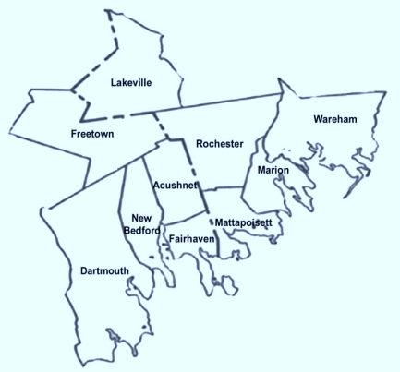
FIGURE 1: SERVICE AREA OF WORKFORCE BOARD
BUZZARDS BAY

ECONOMIC CONDITIONS

Population
The Southeast region accounts for approximately 21% of the state’s residents at the end of the decade. Between 2000 and 2010, the population increased at a modest annual rate of 0.3%. However, there was little growth in the native born population over the decade. Instead, strong annual growth in the region’s immigrant population (2.2%) was the primary factor in the Southeast’s total population increase. The region has seen increased diversity over the past decade, with growing minority populations. The population also became older as baby boomers approached retirement age. This resulted in all cohorts of residents age 45 and older growing during the decade, while nearly all the cohorts of those ages 44 and younger declined.
It is estimated that the southeast should expect to see continued population growth over the next decade but at a slower rate in the future. The region is forecast to add another 39,490 residents between 2010 and 2020. It is estimated that 24% of the region’s population will be over the age of 65 by 2035, compared to 14% in 2010. The trends of a limited growth in the region’s labor force are even more ominous when one considers the fact that southeastern MA employers face a net loss of approximately 135,000 employees who leave the region for work. More specifically, 332,134 individuals are living and employed in the southeast. While 152,536 individuals are employed in the region while living outside, a far more significant number (288,940) who live in the southeast are employed outside the region. This results in a net loss of approximately 135,000 employees who leave the region for work.

Graph: Unemployment Rate Greater New Bedford Area 1991 to present (Source FRED)
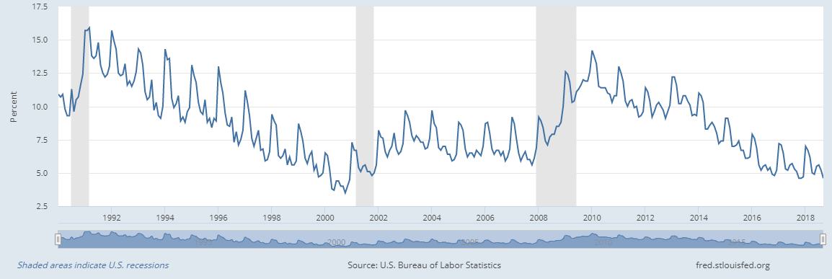
Graph: Economic Growth in Providence-New Bedford Metro Area (Source: FRED)
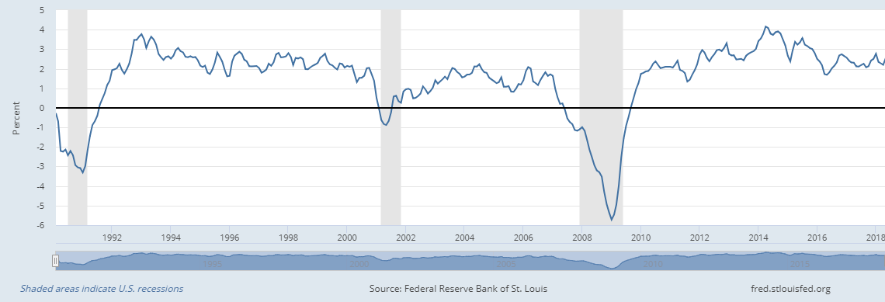

Employment needs of existing in-demand industry sectors and occupations
The priority industry sectors of the region, which encompasses the South Shore, Greater Brockton, Bristol, and Greater New Bedford workforce areas in Southeastern Massachusetts include Healthcare, Professional and Technical Services, and Financial Services. The region also recognizes Manufacturing as a key industry for employers and job seekers. At the local level, additional priority industry sectors are Marine and Maritime and Aviation.

Healthcare
Healthcare however is far easier to predict and to show via analysis reports due to many variables, i.e. the change in our demographics and the aging population living longer as well as advanced technology in medical equipment and detection that sends the patient home or to recovering organizations increasing the need for Home Health Aids and Certified Nursing Assistants. Healthcare organizations and manufacturers alike must become far more creative and pay better to keep positions filled and employees happy.
An initial review of projected occupational growth in each of the four southeastern workforce development areas reveals a concentration of health care occupations among the fastest growing jobs. This includes occupations at the both the entry and advanced levels. The following is a representative listing of health care occupations with significant long-term growth projections. Higher level industry trends clearly translate to the occupational level in this industry sector.
TABLE 2: PROJECTED GROWTH CAREERS IN THE HEALTHCARE SECTOR
Title | Long Term Projected Growth | Average Annual Wage
Home Health Aides | 31.6% | $ 27,675
Nurse Practitioners | 28.7% | $102,041
Occupational Therapy Assistants | 27.8% | $ 59,160
Physical Therapy Assistants | 27.7% | $ 58,496
Physical Therapists | 24.1% | $82,937
Personal Care Aides | 19.5% | $27,236

FIGURE 2: OCCUPATION DATA EMPLOYED IN HEALTH CARE GREATER NEW BEDFORD WDA (MAY 2016)
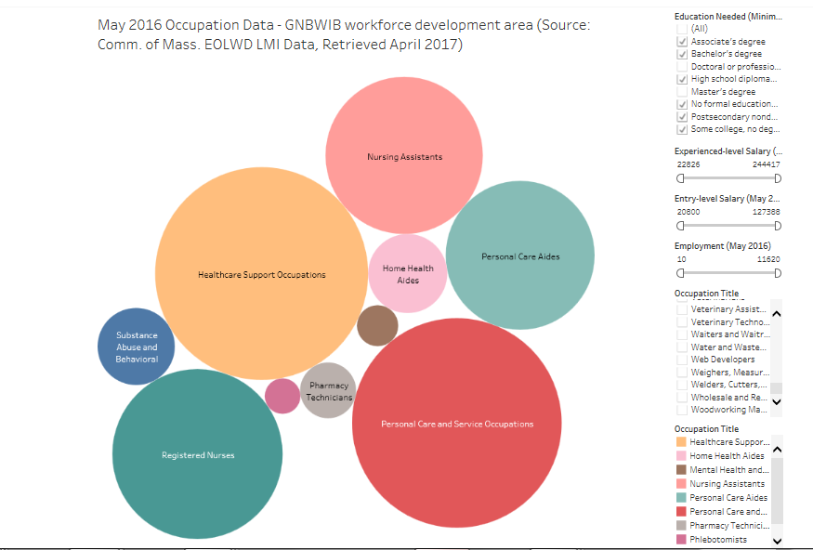
https://masshiregreaternewbedford.com/labor-market/

Professional and Technical Services
Within BA occupations, Software Developers, Network and Computer Systems Administrators, Computer Systems Analysts, Database Administrators and Computer and Information Systems Managers all range from 0.15 to 0.7 qualified individuals per opening. It is evident that these occupations cut across industry sectors with shortages having a ripple effect among many area employers in different fields. Multiple degree programs exist in professional and technical services particularly in computer/IT concentrations including bachelor’s degree programs in Computer Science and Information Technology. Associates degrees and certificate programs include Computer Networking, Computer Technology, Computer Science, Web/Mobile Developer and Computer Network Technician.
From 2013-2016, the Professional and Technical Services sector has seen an 8.7% increase in the number of establishments, a 7.9% increase in employment and an impressive 8.67% increase in average wage. The occupations within this industry are among the highest average weekly wages within the region ($1,505 per week). Meaningful career ladder opportunities are available to those who access additional opportunities. More specifically, significant supply gaps (0.15 to 0.7 qualified workers for each position) are evident in multiple Professional and Technical Service occupations including Computer User Support Specialists, Network and Computer Systems Administrators, Computer Systems Analysts and Database Administrators. While the top levels of the career ladder would in some cases require significant additional training and education requirements, there are opportunities for individuals with more limited skills competencies to enter the industry with relatively short term training interventions. The industry also aligns with regional priorities such as STEM initiatives occurring among education and workforce development partners.

Financial Services
Customer Service Representatives and Tellers are common entry points into the Financial Service Industry with opportunities to secure positions with wages significantly higher than regional median wage. Historically, multiple Presidents of area financial institutions began their career in the industry as a teller. This represents a four-star occupation that provides an entry level access point to career ladders that extends beyond banking to the wide range of within not only the financial services industry but also among nearly every industry that includes insurance representatives, financial advisors and back office support. It represents the highest number of projected jobs (both short and long term) of any four-star occupation in the southeast (10,222 positions in 2017), is among the occupations with the largest number of active job orders in the southeast, and is also ranked as the fourth highest occupation by indexed employer demand (Sub-BA). Regional employers have identified the need to recruit individuals with strong customer service skills. The financial services industry includes a large number of programs in general Business Management and Marketing degree and certificate offerings in the region. In addition, there are bachelor’s degree programs in Financial Management including one with a banking career concentration.

Manufacturing
The current employment needs of manufacturing businesses are growing rapidly but are not reflective of current LMI analysis reports. In manufacturing needs in the areas of precision machinists and welders are growing in numbers that exceeds supply. The growth has crept up quickly and employers are beginning to become concerned with on time deliveries and competitiveness. A challenge for us is to show this growth using these sites because, what is happening now is not yet projected in these reports. We know this through local knowledge, employers who are reaching out reporting vacant positions with continued growth and recent news articles on the growth in manufacturing and the addition of jobs in MA and across the country.
It is important to note that within this sector there are many positions employers are also seeking. More recently, both Titleist and Lockheed Martin have conducted high profile recruiting efforts to hire machine operators, and electro-mechanical technicians that more than meet the statewide living wage standard. Anecdotally, we continue to hear from Small to Medium Enterprise Owners their need for manufacturing work ready applicants to meet production demand.
Manufacturing is a priority industry sector for the Greater New Bedford Area. Below is an interactive dashboard of all manufacturing firms in Region 6, Massachusetts (Greater New Bedford, Bristol, Brockton Area, and South Shore Workforce Development Areas). To explore the data, filter the dashboard on the right by WIB Area, Employee Size, and Town. (Source: Executive Office of Labor and Workforce Development, Massachusetts, Employer Locator).
FIGURE 3: MANUFACTURING EMPLOYERS GREATER NEW BEDFORD WDA 2017
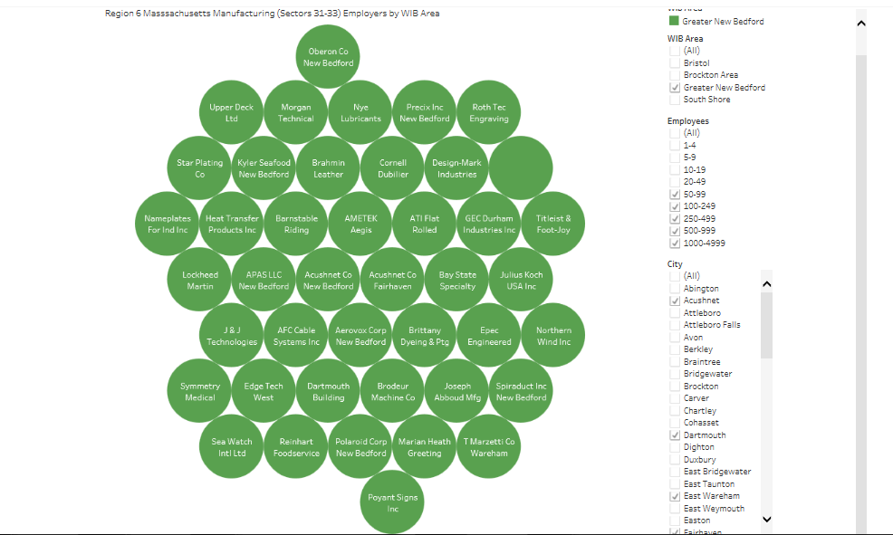
https://masshiregreaternewbedford.com/labor-market/

EMERGING SECTORS
Emerging industries on the South Coast are Marine and Maritime and Aviation.

Marine and Maritime
The maritime services combined with the other, cargo activity, and marinas in the New Bedford and Fairhaven Harbor and seafood processors support 36,578 jobs direct, induced, indirect and related jobs within the Commonwealth of Massachusetts in 2015. Of the 36,578 jobs, 6,225 direct jobs are generated by the seafood activity, marine cargo and marinas, of which, 95% reside in Bristol County. The fishing and seafood industry at the Port of New Bedford creates 5,635 jobs, while the cargo, maritime services and marina activity creates an additional 590 jobs. Jobs related to activity in the New Bedford Harbor accounted for 23,739 jobs. These jobs include downstream logistics operations that are part of the seafood processing, such as warehousing and distribution as well as ultimate sales to wholesalers and restaurants.
Of the 36,578 jobs held by Massachusetts residents that are supported by seaport activity in the New Bedford Harbor in 2105, 1,228 jobs are generated by maritime services, ferry operations, ship repair, cargo operations, and marina activity in the Harbor. Of these 1,228 jobs, 590 direct jobs are generated by this activity and as a result of local purchases made by these 590 direct jobs, an additional 341 induced jobs are generated in the local economy. $32.1 million of local purchases by firms providing services to these Harbor activities supported an additional 297 indirect jobs.
Over the next three years (2019 – 2021), Greater New Bedford will be the regional hub as the launch site for an 800 Mega Watt Off-Shore Wind (OSW) Farm construction project south of Martha’s Vineyard Island. OSW is a sub-industry in marine and maritime. This is the first project of its magnitude in the United States with an additional 800 MW to be awarded in the upcoming year. The contract between the Commonwealth of Massachusetts and Vineyard Wind will employ a myriad of workers. Construction activity related to the deployment of 1,600 MW of OSW is estimated to create between 2,279 and 3,171 direct job-years.2 In total, construction activities are estimated to support between 6,878 and 9,852 job-years, which includes direct, indirect (supply chain), and induced impacts as cited in a recent Massachusetts Clean Energy Corporation report (see Attachment CEC).
By 2021, there will be 660 new job years associated with the Vineyard Wind Project (see Attachment CEC, pg. IX). The Workforce Board has been actively involved in planning and understanding its role to participate in developing pipeline opportunities for residents in its region. Because of the long term implications of new contract awards over the next twenty years, the Board’s strategy includes orienting in-school youth and adult job seekers to the types of jobs available in the upcoming years and skill sets/education required to participate in the industry. Orientation to the industry will be imbedded in all the regional high schools Connecting Activity programs and at the MassHire Greater New Bedford Career Center introductory orientations. Throughout, we will be the hub of information to direct potential job seekers to Bristol Community College, Massachusetts Maritime Academy. Northeast Maritime Academy and UMass – Dartmouth to pursue career path education which meets OSW employment criteria.

Aviation
Aviation is an emerging and local critical priority industry due in part to the presence of a large transportation network on the South Coast and the presence of the regional airport for commercial and individual planes. The key career pathway is the Aviation maintenance technicians who maintain, service, repair and overhaul airframes, power plants, avionics and aircraft instruments. Aviation mechanics frequently are also pilots, which is another key career pathway needed for the area. There is a rising global demand for air travel is creating a shortage of airline pilots. More than 550,000 new airline pilots will be needed by 2034, according to industry projections. Due to the presence of the airport, the transportation hub, and schools, such as Bridgewater State University’s airplane pilot school, there is a shortage and need for these two career pathways. Also emerging is unmanned aeronautical vehicles (UAV) such as drones for both transportation and commercial and scientific applications. The workforce board is actively partnering with employers and local educational institutions at the secondary and post-secondary level to develop frameworks and career pathways to solve business needs for qualified employees in aviation pathways.

INDUSTRY TRENDS
We have two very distinct challenges across all priority sectors.
- The ability of employers to find workers with the right skills sets. Employer expansion in some priority/critical industry clusters is challenged due to their inability to find qualified/credentialed workers.
- The workforce systems ability to grow pipelines of skilled workers as rapidly as employers need them.
Similarly, at the regional level, challenges are:
- The ability of employers to find workers with the right skills sets. Employer expansion in some priority/critical industry clusters are confronting this issue to find qualified/credentialed workers by expressing their needs to area Workforce Boards, Community Colleges and Vocational Technical schools.
- Many jobs seekers and employees lack work readiness skills. Workforce Development and Education partners have initiatives around this issue but in some cases lack coordination in regard to the delivery of appropriate programming. This issue is currently being addressed by the Commonwealth Corporation through the promising pilot introduction of Signal Success currently utilized in youth programming.
- Workforce training and development: Investing in the training and development of entry-level employees, particularly with small businesses, can be challenging due to limited resources, time issues, and lack of knowledge regarding assistance available through workforce development, education and economic development entities. Limited efforts in the past 3 years that were sponsored by the Executive Office of Housing and Economic Development have yielded positive results in regions across the state including Greater New Bedford. Those results included greater collaboration among employers, Vocational High Schools and Workforce Boards to establish baseline training needs aforementioned in this section. This work prompted EOHED to advise the Governor to increase funding for manufacturing training within his FY19 budget. The Governor obliged and the increase was approved by the state legislature. A $625,000 award to provide training in the region is currently in process with the New Bedford WB leading the effort among 4 other WBs, 9 Vocational High Schools, and Cape Cod Cod and Bristol Community College that will increase the employer pipeline for the region by over 200 workers in Year 1. The grant is expected to be recurrent over a five year period.

A number of additional industry concerns (transportation, regulation, energy costs) are not easily addressed by our partnership. Transportation is clearly a significant issue resulting in the labor pool for employers diminished due to job seekers unable to access employment and training throughout the southeast region. As a result, employers have shown a willingness to work with partners to identify creative solutions to transportation issues. As well, potential expansion of commuter rail in the southeast offers a potential opportunity for increase access to education, training and employment opportunities.
In examining industry trends within the southeast region, it becomes clear that recent changes mirror longer term trends that have been seen in this region over an extended period of time. The following represents employment share over the past seven years including percentage growth and decline.
TABLE 3: WORKFORCE IN SOUTHEAST 2009 VERSUS 2016 TRENDS
Industry Sector | Southeast Workforce 2009 | Percentage of Workforce | Southeast Workforce 2016 | Percentage of Workforce | Percent Growth / Decline
Health Care and Social Assistance | 86,517 | 17.1% | 104,514 | 18.8% | +20.8%
Retail Trade | 76,267 | 15.1% | 77,441 | 13.9% | + 1.5%
Accommodation and Food Service | 44,246 | 8.8% | 52,889 | 9.5% | +19.5%
Educational Services | 47,411 | 9.4% | 48,769 | 8.8% | + 2.7%
Manufacturing | 41,944 | 8.3% | 40,450 | 7.3% | - 3.6%
Construction | 24,054 | 4.8% | 35,858 | 6.5% | +49.1%
Finance and Insurance | 30,460 | 6.0% | 30,986 | 5.6% | + 1.7%
Administrative and Waste Services | 21,606 | 4.3% | 27,179 | 4.9% | + 2.9%
Wholesale Trade | 23,647 | 4.7% | 23,905 | 4.3% | + 1.1%
Other Services | 25,484 | 5.0% | 20,736 | 3.7% | - 18.6%
Public Administration | 18,795 | 3.7% | 20,431 | 3.7% | + 8.7%
Professional & Technical Services | 18,853 | 3.7% | 20,333 | 3.7% | + 7.9%
Transportation and Warehousing | 14,624 | 2.9% | 17,870 | 3.2% | +22.2%
Arts | 6,954 | 1.4% | 10,163 | 1.8% | +46.1%
Management | 9,685 | 1.9% | 9,478 | 1.7% | - 0.2%
Information | 9,525 | 1.9% | 9,173 | 1.7% | - 0.2%
Utilities | 2,821 | 0.6% | 3,070 | 0.6% | + 0.1%
Agriculture | 2,115 | 0.4% | 2,214 | 0.4% | + 0.1%

KNOWLEDGE AND SKILLS ASSESSMENT
To meet employer needs for specific skills and knowledge from their employees, the workforce board:
- Performs analyses of the economic conditions in the region to learn the needed knowledge and skills of the region, learn about the workforce of its region, and workforce development activities it needs including education and training described in WIOA §108(b)(1)(D), and regularly updates such information;
- Continues to assist the Governor in developing the statewide workforce and labor market information system described in §15(e) of the Wagner-Peyser Act (29 U.S.C. 491-2(e)), specifically in the collection, analysis, and utilization of workforce and labor market information for the region;
- Conducts other research, data collection, and analysis related to the workforce needs of the regional economy after receiving input from a wide array of stake-holders and then determines training necessary to carry out these functions;
- Conducts future analysis on emerging industries such as offshore wind and marine trades where growth within the next 3-5 years will affect the Southeast Region.

Healthcare
The Healthcare industry faces significant workforce development challenges. From a labor force standpoint, multiple important occupations within this industry face supply gaps resulting in labor shortages. Supply gap analysis shows most positions with low ratio of qualified individuals per opening (0.1to 0.9 per opening) with occupations such as Nursing, Physical Therapy Assistant, Licensed Practical Nurse, Medical Records and Health Information Technicians, Dental Hygienists, Nursing Assistants and Radiologic Technicians showing long term supply gaps in the southeast. The struggle in developing a talent pipeline for this industry is affected by limited training and education capacity in the region for certain for occupations. For example, there is only one Associates Degree program in Radiologic Technology in the southeast region and the limited number of slots in Registered Nurse degree programs impacted by lack of teaching capacity is well documented. All this is occurring against the backdrop of ongoing changes in the healthcare industry and the unquestioned trend for increase demand for services forcing providers to move toward redesigned primary care models away from acute hospital utilization.

Professional and Technical Services
Professional and Technical Services offers a range of high level services and with few exceptions employers within this sector engage in activities that require high levels of expertise, advanced training and degree attainment. This has translated into strong growth prospects and high wages, and has shown a steady growth rate of 8% from 2013-2016. As well, wages in this industry have increased 8.67% over the same period representing the fourth highest average weekly wage in the southeastern region ($1,505). The industry also has the third highest number of establishments in the region (3,748). In addition, many of the occupations within this sector, particularly in computer/IT occupations cut across multiple industry clusters. In most of these cases, the jobs are high demand (4 and 5 Demand STARS) rating and show strong projected growth. Examples include Computer Systems Analysts (16.4% projected long term growth) and Computer User Support Specialist (11.1% projected long term growth). It is also significant to note that attracting industry within this sector is a regional economic development priority supported by both the workforce development and education sectors. To illustrate the point with one example, the Southeastern Regional Planning and Economic Development District’s (SRPEDD) Comprehensive Economic Development Strategy, Life Sciences already make up a majority of employment within the knowledge and technology-intensive industry clusters throughout the region. The same report cites efforts throughout the region to attract bio-tech companies to the area, further noting the MA Biotechnology Council ranks several area communities as “BioReady”. These efforts have been replicated in the region for different occupational clusters in an ongoing effort to attract knowledge based occupations that offer high wages and career ladder opportunities.

Financial Services
The financial services sector is an industry that in recent years has faced dramatic changes in its operations and it appears that such trends will continue. Technology has been integrated into consumers’ lives at a rapid pace. This has had significant residual effects in the financial service industry with demand for services growing but fewer people visiting banks. Online portals and self-service kiosks are examples of technologies that have streamlined services and changed the face of the labor force. Still, the industry shows steady employment growth and importantly, significant wage growth (12.45% from 2013-2016). On a talent development level, financial institutions often used the entry level teller position as the most common access point to career ladder progression but this has lessened somewhat as the industry has adopted a “Universal Banker” model. Representing many skill sets required by a Customer Service Representative, the Universal Banker provides customer service across a wide range of traditional financial services such as basic transactions, new accounts, and loan applications. In 2015, the Bank Administration Institute named increased implementation of universal bankers as one of the most anticipated trends in retail banking. A significant challenge to the industry is that these and similarly situated positions require significant cross training. In addition, there is a lack of training and education programs in the region that are specific to entry level positions in financial services. Feedback from local employers reveals customer service, problem solving, work readiness skills, interpersonal skills, teamwork, financial literacy and writing skills as core competencies to succeed in the industry. Additional workforce challenges articulated by local employers include difficulty in identifying and recruiting a more diverse and multi-lingual workforce, challenges in attracting younger workers into the industry who often do not see the available career pathways, and the desire to “home grow” employees. Leaders in the industry have investigated several strategies to address some of these issues including an effort to establish apprenticeships in the region through such mechanisms as internships. Clearly, these initial efforts would benefit from additional supports in the region as the region’s financial services sector has not been as systemically connected to the skills cabinet divisions as some other industries.

Manufacturing
Within the manufacturing sector, multiple labor supply gaps exist and are likely to increase in the near and longer term. The manufacturing sector is marked by an aging labor pool in the southeast with 34% of the workforce over the age of 55. As a result, the industry faces large scale attrition over the next 5-10 which has been confirmed through feedback from the region’s manufacturers, particularly among members of the Southeast MA Advanced Manufacturing Consortium. This issue is compounded by the fact that the region has a limited training pipeline to develop the future workforce in this industry. The region’s vocational technical high schools provide valuable programs and a supply of graduates who enter the manufacturing field, but this number does not meet the demand or level for skilled employees in this industry. While additional training opportunities for adults exist through partnerships among workforce boards, vocational technical high schools and community colleges and some credentialing is present (i.e. MACWIC), the programs are not as formalized as in other industry clusters and in many cases, lack systemic funding. Another contributing factor in the limited talent pipeline is the perception among area youth that manufacturing is a declining industry that does not offer strong career ladder opportunities or good wages.

Marine and Maritime
Marine and Maritime include careers onshore and offshore. They include careers in a variety of sectors including scientific and technical services, recreation, hospitality, transportation and logistics, professional and technical services, and food services. Major job categories on the South Coast include cargo transportation, vessel operations, SCUBA diving,
Cargo Marine Transportation - Participants in this category are involved in arranging for overland and water transportation for export or import freight through the seaport. The freight forwarder/customhouse broker is the major participant in this category and arranges for the freight to be delivered between the Port of New Bedford and inland destinations, as well as the ocean transportation. This function performed by freight forwarders is most prevalent for general cargo commodities. For bulk cargo, arrangements are often made by the shipper/receiver.
Vessel Operations - This category consists of several participants. The steamship agents provide a number of services for the vessel as soon as it enters the New Bedford/Fairhaven Harbor, including arranging for pilot services and towing and for ship supplies. The agents are also responsible for vessel documentation. In addition to the steamship agents arranging for vessel services, those providing the services include:
Pilots - assist vessels navigating to and from the Port of New Bedford terminals
Chandlers - supply the vessels with ship supplies (food, clothing, nautical equipment, etc.)
Towing firms - provide tug assist service to vessels docking and undocking at a terminal
Bunkering firms - provide fuel to the vessels
Marine surveyors - inspect the vessels and the cargo
Shipyards/marine construction firms - provide repairs, either emergency or scheduled, and marine pier construction and dredging.
Cargo Handling involves the physical handling of cargo at the Port of New Bedford between land and the vessel. Included in this category are:
Longshoremen - are members of the International Longshoremen’s Association, involved in the loading and unloading of cargo from the vessels, as well as handling the cargo prior to loading and after unloading
Stevedoring firms –manage longshoremen and cargo-handling activities
Terminal operators - are often stevedoring firms who operate the maritime terminals where cargo is loaded and off-loaded
SCUBA divers
Career options - there are different types of working divers, each demanding different skills and competencies. These include:
Offshore Diving in support of the offshore oil and gas industries. Usually it is contract based.
Inland / inshore diving, for example, in support of civil engineering or marine-related projects and fish farming.
Scientific and Archaeological Diving in support of scientific research and education, and archaeological investigation of sites of historic interest.
Media Diving in support of film or TV productions which require divers to work as stunt performers, journalists, presenters, photographers, camera operators, sound and lighting technicians, and unit crews.
Recreational Diving involving the instruction and guiding of recreational divers.
Police and Armed Forces. These divers are specialists who are chosen from personnel already in the service.
The Government Agencies maritime service sector category involves federal, state and local government agencies that perform services related to cargo handling and vessel operations at the Port of New Bedford. These include U.S. Customs and Border Protection, U.S. Environmental Protection Agency, U.S. National Oceanic and Atmospheric Administration, and U.S. Coast Guard.
Marinas and Ferry Boat Operations - this includes those employed by the seven recreational marinas located in the Harbor which moored approximately 570 recreational boats in 2015. This also includes employees involved with the ferries located in the Harbor that travel to Cuttyhunk Island, Martha’s Vineyard, and Nantucket as well as a water taxi that also sails to Cuttyhunk.
Port of New Bedford - this sector includes those individuals employed by the New Bedford Harbor Development Commission to oversee port activity.
Federal agencies charged with regulating offshore and maritime workplace safety have yet to develop specific guidelines for the OSW industry. Outside of the development of new regulations, the U.S. Coast Guard, Occupational Safety and Health Administration (OSHA), and BOEM have guidelines in place for worker safety at sea, in construction, and in long-shoring, which all apply to OSW. Fortunately, the major developers and manufacturers involved in the Massachusetts OSW industry have experience in industry developed safety standards through their European connections, such as the Global Wind Organization (GWO) and BZEE (Bildungszentrum für Erneuerbare Energien).
The Maritime Industry has great near future needs for skilled labor. The dozen plus maritime companies noted below have a need for nearly 300 skilled openings. This does not include the expected jobs that will be created due to the implementation of offshore wind initiatives scheduled for 2020.
Offshore Wind will involve training on several different levels depending on the phase of the project such as:
Back Deck & Below the Water
- Back Deck Workers
- Cable Laying/Installing – also requires deep underwater divers
- Commercial Divers
- Foundations/Jackets/Transition Piece
- Remotely Operated Vehicle (ROV) Operations
- Health & Safety
Above-the-Water
- Turbine Installation Technicians
- Turbine Operations & Maintenance Technicians
Offshore Marine Safety
- Helicopter Underwater Escape Training (HUET)
- Turbine Transfer Vessel
- Standards of Training, Certification and Watch-keeping (STCW)
- Firefighting
- When we reference how the Maritime and Offshore Wind Industries are linked, these training show the significance of what this means.
- Vessel crew training and certification – STCW
- Vessel to Turbine Transfer; space to install dockside transition piece on campus to train on
- Safe transfer training from vessels and ladders to platforms
- Training for all in rescue of person in water
- Confined space rescue, rescue from heights and depth in same unit.
- Partnering with Gardline

Offshore Wind
The occupations listed below are plotted out within the three phases of offshore wind through 2030. We are challenged to predict how many of these jobs will be needed locally to satisfy growth initiatives off of Nantucket sound, an offshore wind development of over 120 wind turbines. Still in order to be proactive, we must start the process of growing a labor force that has changed very quickly and one where most of our experienced labor force has already left the workforce arena taking their experience and knowledge with them. The other challenge is that the schools and universities are just beginning to change, create and offer curriculum that will help to grow the pipeline of workers needed for both growing and emerging industries of Maritime Marine and Offshore Wind.
The development of 1,600 MWs of offshore wind energy wills kick-start a new and emerging industry in our region. Over 3,600 local full time equivalent jobs is expected over the life of the project starting with in-state construction in 2019.
Trade workers play a significant role during the construction of the wind farm, including electricians, steel workers, pile drivers, crane operators, painters, longshoremen, machine operators, commercial divers, construction laborers, and others. These skilled workers will play a central role in the construction, assembly, and deployment of offshore wind projects. As much assembly as possible is performed onshore, but some trade workers perform their duties offshore as part of the final installation and commissioning of the wind farm.
OSW developers active in the Massachusetts market will also require that we provide health and safety training for onshore and offshore construction workers and maintenance technicians. Consequently, investing in health and safety training programs and facilities will be essential to enabling a local workforce to participate in and benefit from the development of an OSW industry in Massachusetts.
The Board collaborates with a variety of workforce partners to identify employment needs of the region’s employer base, and respond proactively to those needs. To ensure training is available, staff continuously works with the Eligible Training Provider System (ETPS) providers to keep the training list relevant. If training for a particular occupation is not available in the region, the Board works to identify training providers and encourage them to become certified through ETPS i.e. machine technology/advanced manufacturing, marine trades& technology basic certification, MIG welding.

LOCAL ANALYSIS OF LABOR MARKET
Our website houses all of our data in the form of Performance Dashboards that we use to analyze and make regular updates of our economic conditions so that we know what the needed knowledge and skills, workforce, and workforce developments (including education and training) activities to use to make our prediction for future planning, grant application and training programs. These dashboards present data visualizations of workforce information including:
Area, State, and National Unemployment Rates (March 2016 to current) (Updated May 2017). Graph charts unemployment data for the 10 municipality area of the Greater New Bedford Workforce Investment Board, Massachusetts, and the National rate.
Occupation Data for the local workforce development area (May 2016)
Occupation Data for the GNBWIB area including occupations by education type, entry and experienced annual salary, and occupation type. The graph depicts occupations by employment size, with the larger circles indicating occupation groups with the most employment in the area. Filter the graph by using the filters to the right and hover over each circle to read more detailed information on each occupation.
Hourly and Annual Wages by Occupation in the Greater New Bedford Area is a dashboard of annual and hourly mean wages per occupation in the Greater New Bedford Workforce development area of Massachusetts. Filter the data by number of employed in the occupation, annual and hourly mean wages. Click on the tabs for more views and data exploration. (Source: Occupation and Employment Statistics, Bureau of Labor Statistics, May 2015).

GNBWIB Area 2010-2015 Total Wages, Average Wages, and Total Employment (Filter by Town) is a dashboard of total and average wages for the area with filters by town. Includes total employment for region (and filters by town) and total establishment details. (Source: Executive Office of Labor and Workforce Development, Massachusetts, All Towns 202 Data, Labor Market Information).
GNBWIB Area Labor Force Participation, Unemployment, and Employment – February 2016 to current (updated 5/26/2017) is an interactive dashboards on labor force participation in the GNBWIB Area with data and filters by town. View unemployment rate for all towns or filter by individual town. Hover over each bar on the labor force participation to view all employed and unemployed, or filter by towns to see details for each area. (Source: Executive Office of Labor and Workforce Development, LMI Data http://lmi2.detma.org/lmi/lmi_lur_a.asp).

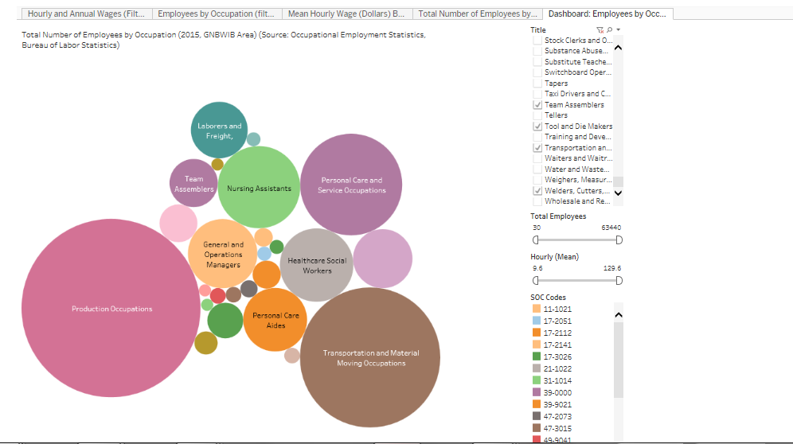

GRAPH: Labor Force Participation 2016 and 2017 in Greater New Bedford Area
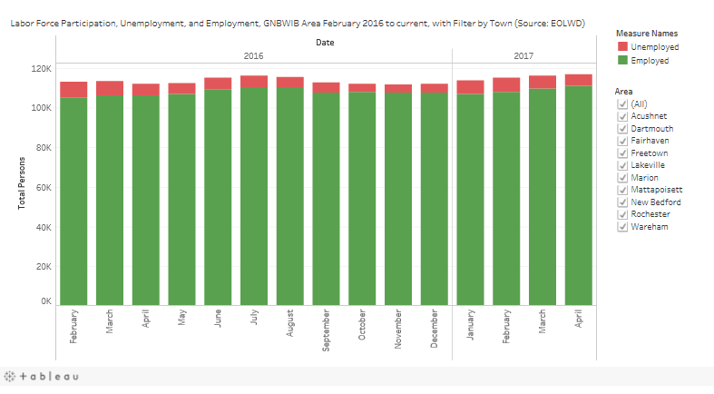
Barriers to employment for the unemployed and underemployed as well as individual growth for incumbent workers are major challenges for our area. Many employers tell us that a lack of proficiency in applied math skills is one of the most common barriers; however, low-level reading skills and a lack of familiarity with computer technology are also often barriers to hiring and training opportunities. Another challenge is a lack of critical “soft skills” such as communications; teamwork, reliability, and problem-solving disqualify others from hiring and promotion opportunities. As a result of these barriers, many less-skilled production workers or potential entrants find themselves stuck in dead-end jobs or experiencing long-term unemployment, while positions requiring higher-level skills go unfilled. We continue to strive and create best-practice programs working with our vocational and community colleges including other manufacturing entities like Southeastern MA Advanced Manufacturing Consortium and MA Manufacturing Extension Partnership out of Worcester that offer high-quality manufacturing training to help bridge the gap between potential candidates and the skill needs of employers to include career readiness.
Other barriers to employment in our priority sectors is speaking and understanding the English language; English literacy and adult education. Adult education and literacy activities are a critical part of the local workforce initiatives in the Greater New Bedford and South Coast area of Massachusetts. In our 10 municipality region, the population demographics of five of the municipalities are below the area average of 88% for high school degree attainment (all ages) – Freetown (87%), Fairhaven (86%), Acushnet (83%), Dartmouth (81%), and New Bedford (72%). Two municipalities are below the average High School graduation rate for the area of 84%, Wareham (76%) and New Bedford (60%), both of which exceed the average drop-out rate for the area of 7% (13% and 17% respectively).
For a single adult with children to earn $30.56 per hour, which is a prevalent statistic and characteristic of families in the GNBWIB area, according to Labor Market Information data (EOLWD, 2015; Living Wage Calculator, MIT, 2017) there are zero entry level positions paying the living wage for one adult without a minimum of a high school degree and two children. Of the local position types which pay this wage, the majority require at least a high school degree and then technical training expertise, such as electricians, mechanisms, plumbers, managers and supervisors, operating engineers, or, police officers. For two adults with two children, only one position does not require formal education, bricklayers or brick-mason assistants (EOLWD, LMI data, 2015).
Thus, adult literacy and education is critical to workforce initiatives by providing adults with access to training and education to meet the demands and requirements of local employer job opportunities. The board aligns workforce investment through a data-driven and person-centered approach, focusing on area employment needs and working developing training and education initiatives to meet these demands, as well as meet the living wage needs of the local population.
Many of occupations in this region require knowledge and skills in the STEM (science, technology, engineering, and math) subjects. This is a recurring theme, not only for in-demand occupations, but also for in-demand industries, with many STEM-oriented occupations and knowledge/skill sets crossing industries.
It is however becoming increasingly difficult to know what the future job market will look like with fast advancements in technology such as automation, sensors, software and even artificial intelligence. Although labor market data can provide robust occupational projections, job titles are becoming obsolete. Skills are the new name of the game for young or seasoned individuals who want to succeed in today’s and tomorrow’s labor markets. The following chart is skills employers need job applicants to possess
TABLE 4: 21ST century InDemand Job Skills
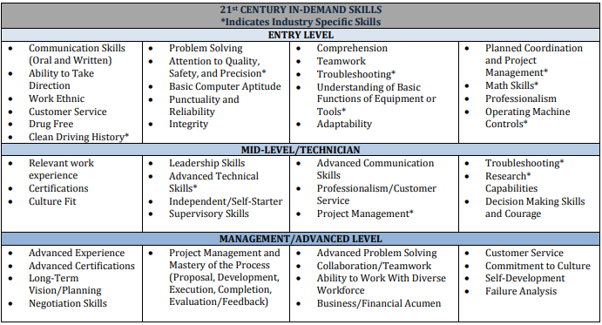

WORKFORCE DEVELOPMENT ACTIVITIES
Workforce development activities in the New Bedford Region are designed to align with current and future needs of employers. All parties are communicating, collaborating and participating in understanding demand and seeking innovative solutions to match or upgrade its human resources in order to fulfill labor needs.

Strengths and Weaknesses
The heart of the effort of the Workforce Board is to create strong partnerships that understand the system’s ability to deliver education and training that will create economic opportunity. We understand the following:
Strengths
Several local community colleges offer training in growth occupations
Availability of customized training options through the community colleges
Frequent enrollment windows in many Adult Education classes
Area involvement with multiple partners for client strategies
Essential Skills Training
Customized labor market information
Advisory boards, at community colleges and vocational schools for manufacturing and logistics, do a good job in providing direction for training programs.
There is a long history of engaged workforce board members
Strong existing local partnerships among various core partners and required partners
Weaknesses
Aging workforce and also inability to recruit younger generation into entry level
Business Services representatives are inexperienced and require more in depth training
There is no formal business calling strategy in place to determine occupational needs
Referral process needs strengthening with improved follow up and documentation and there is no integrated shared information system for core partners and required partners however this process is being worked on by the State and local area
More employers need to use available resources in the area of incumbent worker training
Apprenticeship initiatives/programs need to be further developed at the MassHire Greater New Bedford Career Center level

Training and Education Programs
The existing training programs for manufacturing in the Southeast Region are excellent for preparing job seekers to enter and retain employment with businesses. We have made it easier for job seekers in need of training to be able to choose and commute between five workforce areas in the region to maximize their training options.
The Workforce Board has developed a strong capacity over several years through the receipt of manufacturing related training grants from an array of sources that included Mass Technology Development, and the Executive Office of Housing and Economic Development (EOHED). Most prominently, the New Bedford Regional Board has received several hundred thousand dollars to provide entry level industry recognized credentials necessary for success in a manufacturing environment. In addition, it has evolved some basic welding instruction efforts to a MIG-TIG training program to meet local employer demand.
The New Bedford Board is currently leading the five workforce regional effort as aforementioned. The effort will be sustainable for four additional years to address skills gap needs of our regional employers.
Training providers e.g. vocational technical schools, have advisory boards consisting of employers and workforce partners to ensure the programs they are offering training in meet employer expectations. In addition, workforce development and education partners have Career Pathways to prepare individuals to be successful in post-secondary education and enter or advance within occupations. Community colleges offer credentials in many sectors that can be stackable. Career advisors/planners provide goal-setting, academic advising, and enrollment assistance. Future training for other sectors is slated to follow the same modality as described here.
Future training for other sectors is in planning or early implementation with intent to follow the same modality as described here. Some examples of the Workforce Board’s future sector activities include:
Collaborating with three regional high schools to introduce Chapter 74 educational curriculum germane to both the local region and regional priority industry sectors. They include:
New Bedford High School’s application to create an approved Chapter 74 Finance curriculum that will be the only one of its nature in the state. It has also applied for a Capital Skills Grant to install a new “state of art” finance lab.
Greater New Bedford Vocational Technical High School recently introduced a 45 hour industry recognized Marine Trade Skills program in response to local maritime industry needs. The Workforce Board brokered the course offering in coordination with an Executive Board member of the Mass. Maritime Trade Association.
GNB Voc-Tech is in the process of a Chapter 74 application to offer Aviation Mechanic training in response to a growing demand of both commercial and general aviation needs. Much like other skilled industry sectors demand will continue to be steady over the next decade as noted in a recent Bureau of Labor Statistics report cited below. Locally, there are both school to career and school to college opportunities. Career opportunities exist at several general aviation airports that include, New Bedford Regional Airport that houses three Fixed Base Operators that cater to recreational, commuter, and jet aircraft. New Bedford continues to add privately owned hangars, housing new jets, planning for new business growth to host corporate charter facilities and increasing commuter routes to destinations beyond the Cape and Islands.
Voc-Tech students will also have an opportunity matriculate to an Educational Pathway to the Bridgewater State University Aviation Degree program. The University is not only 45 minutes from the New Bedford region, but also has a presence at the New Bedford Regional Airport where the school administers its flight school program.
TABLE 5: Employment Projections Aviation 2016-2016
Occupational Title | SOC | Employment 2016 | Projected Employment 2026 | Change, 2016-26
 |  |  |  | Percent | Numeric
Aircraft and avionics equipment mechanics and technicians | — | 149,500 | 157,000 | 5 | 7,500
Avionics technicians | 49-2091 | 17,500 | 18,600 | 6 | 1,100
Aircraft mechanics and service technicians | 49-3011 | 132,000 | 138,500 | 5 | 6,400

The Board believes that Apprenticeship is also a great strategy to train job seekers as well as assist employers with succession planning hence the Board assures promotion of apprenticeship as a viable workforce development strategy to address growing skill gaps, and as a solution benefiting job seekers and business alike.
In partnership with Massachusetts Division of Apprentice Standards (the State Apprenticeship Agency in Massachusetts) and economic development and education, registered apprenticeship programs will be developed that:
are designed around the training needs of the employer/industry
are industry recognized
provide apprentices, upon completion of the program, a portable, nationally recognized credential.
All sponsors of registered apprentice programs will be notified of their eligibility to be placed on the Eligible Training Provider List (ETPL).
Grant funds (Massachusetts Apprenticeship Initiative, Apprenticeship Accelerator, and Massachusetts Apprenticeship State Expansion grants) will be utilized to:
a. Engage businesses in new and traditional industries to encourage development of new programs
b. Recruit and serve women and under-represented populations
c. Align state systems, capacity and subject matter expertise to embed apprenticeship as a key training vehicle for employers in the state.

BARRIERS TO EMPLOYMENT
The MassHire Greater New Bedford Workforce Board core partners and required partners will collectively use the following goals to support our vision to align and integrate education, workforce and economic development strategies at the state, regional and local levels to improve the economic growth and competiveness of the state’s employers and their workforce that includes all individuals according to WIOA Sec. 3 (Def.24-25).
We collaborate to foster improvement and expansion of employer-driven, regional sector partnerships to increase the focus on critical in-demand occupations in key sectors that are the engine of economic growth for the state and its regions. Advisory committees of interested sector employers, for all priority sectors will be formed, to gather specific employment data that would be shared among the partners.
Expand career pathway opportunities through more accelerated and work-based training and align and integrate programs of study leading to industry-recognized credentials and improved employment and earnings. The Workforce Board continues to work with existing employer sector groups including and vocational technical schools and community colleges, to expand career pathway opportunities through more accelerated training and work-based learning, leading to industry recognized credentials, resulting in improved employment and earnings.
Expand career services and opportunities for populations facing multiple barriers to close the gap in educational attainment and economic advancement through career pathways and improved career services and expansion of bridge programs. The workforce board will continue to expand career services and opportunities for special populations of all types, facing barriers to educational attainment and economic advancement will be achieved by:
Our continued efforts to work closely with local community college partners in bridge programs
Provide work-based training for those who qualify for Title V services
Co-enroll individuals with local partner programs, as needed to assist those with multiple barriers to become successful
Expand information for employers and job-seekers to access services by improving the MassHire Greater New Bedford public-private data infrastructure to support the alignment and integration of economic development, workforce development and education initiatives for supporting sector partnerships and career pathways.
Our goals are supported by:
Participation in the region’s several workforce development initiatives of regional Chambers of Commerce and United Way organizations
Supporting our Economic Development Council (EDC) through membership
Creating public – private partnerships or alignments with businesses and not-for-profit agencies that serve special populations
Improving public / private data infrastructure by collecting regional data and investigating methods to make the data accessible
Looking for opportunities to make presentations to economic development practitioners and professionals, through chambers of commerce and economic development association
Connecting with entrepreneurs and those starting businesses, to assist with workforce needs

BUSINESS EMPLOYMENT NEEDS
The goal of the Board is to be the primary provider of human capital to employers in our service delivery area as well as regionally. The Region 6 workforce systems serve as a central point of contact for employers and promote knowledge and continuing use of workforce services. The Board has established an employer-driven system dedicated to sustaining and promoting business development in the region. Providing quality, value-added services to local employers allows us to propagate the relationship between employers and job seekers.
The Board leads in the effort to ensure we engage a diverse range of employers by;

Promoting business representation of our Board
Developing effective linkages with employers in the region to support employer utilization of the local workforce development system and support local workforce investment activities
Ensuring that workforce investment activities meet the needs of employers and support economic growth in the region, by enhancing communication, coordination, and collaboration among employers, economic development entities, and service providers
Developing and implementing proven or promising strategies for meeting the employment and skill needs of workers and employers (such as establishment of industry or sector partnerships that provide the skilled workforce needed by employers in the region
Expanding employment and career advancement opportunities for workforce development system participants in in-demand industry sectors or occupations
Our service delivery model for employer engagement is focused around the workforce board’s key contacts with employers and board membership as well as our contacts within the New Bedford Business Park and the Business Directory of our local Chamber, SouthCoast Chamber. The second level is our Business Services Representatives (BSR) at the MassHire Greater New Bedford Career Center. BSR works with area employers by posting openings in the MOSES and Job Quest systems. A recent enhancement now allows employers to independently post information on Job Quest. BSRs will also screen and refer qualified applicants and provide local intelligence such as labor market information to employers in need.
In addition, BSRs assist employers with business expansion opportunities by providing information regarding Work Opportunity Tax Credits and On-the-Job Training allowing employers to save time and money. Employer outreach and engagement are crucial, and as such, we have increased the BSR position by two covering the city of New Bedford and nine other towns within our region. These staff members are currently in training to work closely with area businesses to identify needs such as current labor pool skills gaps and supply linkages to local training providers to ensure a skilled and ready workforce exists to meet employer needs. These services increase employer capacity and allow employers to be more competitive in the current local economy.
Employer forums, focusing on manufacturing, which involved all core partners in the presentation of partner services, an assessment of business needs, and the identification of critical skills for new hires have recently been held in various parts of the region. These events include a dialogue between workforce partners, area manufacturing representatives, and local educators. It is the intent is that this dialogue will be continued after the forums to insure that workforce partners and educators are responding to the needs of area manufacturers. The offering of additional sector forums will also be considered.
To facilitate engagement of employers in workforce development programs, including small employers and employers in in-demand industry sectors and occupations we continue to pursue data-driven collection activities that strive for as close to real-time, detailed demand data regarding positions and the individual tasks involved in the positions. This includes also pursuing data-driven activities that strive for detailed demand data regarding immediate available positions and projected positions for 3 and 5 years forward.
The Southeast Region has been focusing on sector partnerships to better serve the needs of businesses. Regions 6 & 7 have applied for a five year grant through the Executive Office of Housing and Economic Development to grow a pipeline of skilled job seekers both new and incumbent workers for the manufacturing sector. The expectation is to train over 1,200 individuals to become skilled machinists and welders helping area and regional companies to fill gaps and stay competitive.

VISION TO SUPPORT REGIONAL GROWTH
The workforce board has established goals for preparing an educated and skilled workforce (including youth and individuals with barriers to employment), and goals relating to the performance accountability measures based on performance indicators described in § 677.155(a) The goals are listed in the Local Performance Goals section.
The regional strategy to work with entities including businesses and educational partners to align resources available are listed in the goals at the beginning of the documents. These include for each of the priority industries to identify business demand, to convene all partners and to align WIOA and other funding to meet the needs of employers in the region. By strategically aligning resources and convening related and interested parties, a concise strategy will occur to support regional growth.

ACCORDANCE WITH WIOA SECTIONS 108(b) (2)–(21))
The Board strives to provide superior service to all customers. WIOA offers a comprehensive list of core programs for job seekers in the Southeast region. Programs are provided at MassHire Greater New Bedford Career Center location and include:
Services or refer services related to the six core AJC network programs: Title I Adult, Dislocated Worker, and Youth programs; Title II Adult Education and Family Literacy Act program; Wagner-Peyser Act Employment Services programs as amended by Title III of WIOA; Vocational Rehabilitation program as authorized under Title I of the Rehabilitation Act of 1973, and as amended by Title IV of WIOA, and other programs as designed by WIOA through Partners;
Provide job seekers with the skills and credentials necessary to secure and advance employment with wages that sustain themselves and their families;
Provide access and opportunities to job seekers, including individuals with barriers to employment as defined in WIOA § 3(24);
Enable businesses and employers to easily identify and hire skilled workers and access other human resource assistance including education and training for incumbent workers, assistance with pre-screening applicants, and other forms of business related assistance;
Participate in monitoring and evaluation that support continuous improvement of the MassHire Greater New Bedford Career Center;
Ensure that high-quality integrated data informs decisions made by policy makers, employers, and job seekers;
Disclose any potential conflicts of interest arising from the relationships of the lead operators with particular training service providers or other service providers;
In coordinating services and serving as the Lead Operator, refrain from establishing practices that create disincentives to providing services to individuals with barriers to employment who may require longer-term services, such as intensive employment, training, and education services;
Comply with Federal, State, and WIB regulations, and procurement policies relating to the calculation and use of profits and reporting and submission of its fiscal activities.

Additionally, the Lead Operator shall:
Facilitate integrated partnerships that seamlessly incorporate services for common customers;
Develop and implement operational policies that reflect an integrated system of performance, communication, and case management, and uses technology to achieve integration and expanded service offerings;
Organizes and integrates services by function (rather than program) where permitted by a program’s authorizing statute.

The Lead Operator will ensure that and submit evidence through Monitoring of:
MassHire Greater New Bedford Career Center staff are trained and equipped in an ongoing learning environment with the skills and knowledge needed to provide superior service to job seekers;
MassHire Greater New Bedford Career Center staff are cross-trained as appropriate to increase staff capacity, expertise and efficiency;
MassHire Greater New Bedford Career Center staff is routinely trained on their duties, and cross-trained as appropriate, so they are keenly aware as to how their particular work function supports and contributes to the overall vision of the local workforce development board area and the broader AJC network.

Basic Career Services
At a minimum, all of the basic career services described in WIOA §134 (c) (2) (A) (i-xi) and 20 CFR 678.430(a), 34 CFR §361.430(a), and 34 CFR §463.430(a) must be provided in each local area through the MassHire Greater New Bedford Career Center, including, but not limited to:
Determination of program eligibility, such as adult, youth, or dislocated programs;
Outreach, intake, and orientation on other services available in the workforce system;
Initial assessment of skill levels;
Labor exchange services including job search and placement assistance;
Referrals to other relevant programs and services;
Accurate workforce and labor market employment information;
Provision of performance information and program cost information on eligible providers of training services;
Provision of information in usable and understandable formats and languages related to performance accountability measures, supportive services or assistance, and appropriate referrals;
Assistance in establishing eligibility for financial aid assistance for training and education programs not provided under WIOA;
Customers that require assistance of any services have trained staff members available to answer questions and assist them.
Provision of information and assistance regarding filing claims under UI programs.

Individualized Career Services
MassHire Greater New Bedford Career Center staff pursuant to 20 CFR §678.430(b), 34 CFR § 361.430(b), and 34 CFR §463.430(b) shall provide individualized career services after a determination by assessment, including, but, not limited to:
Comprehensive and specialized assessments;
Development of an individual employment plan;
Group or individual counseling;
Career planning;
Short term pre-vocational services;
Internships and work experiences linked to careers;
Workforce preparation activities (34 CFR§463.34);
Financial literacy services (WIOA §129(b)(2)(D) and 20 CFR §681);
Out of area job search assistance and relocation assistance;
English language acquisition programs (34 CFR§ 463.31, 34 CFR §463.35);

Follow up Career Services
Pursuant to 20 CFR §678.430(c), 34 CFR §361.430(c), and 34 CFR§ 463.430(c) follow-up services must be provided as appropriate for up to 12 months after exit.

Our Board assures that we will coordinate activities with education and training providers in the local area, including providers of workforce investment activities, providers of adult education and literacy activities under title II, providers of career and technical education (as defined in section 3 of the Carl D. Perkins Career and Technical Education Act of 2006 (20 U.S.C. 2302)) and local agencies administering plans under title I of the Rehabilitation Act of 1973 (29 U.S.C. 720 et seq.), other than section 112 or part C of that title (29 U.S.C. 732, than section 1112 or part C of that title (29 U.S.C. 732, 741).

The MassHire Greater New Bedford Workforce Board reviews the applications to provide adult education and literacy activities under title II for the local area, submitted under such section to the eligible agency by eligible providers, to determine whether such applications are consistent with the local plan; and makes recommendations to the eligible agency to promote alignment with such plan

The MassHire Greater New Bedford Workforce Board will replicate cooperative agreements in accordance with subparagraph (B) of section 101(a)(11) of the Rehabilitation Act of 1973 (29 U.S.C 721(a)(11), and implementing cooperative agreements in accordance with that section with the local agencies administering plans under title I of that Act (29 U.S.C. 720 et seq.) (other than section 112 or part C of that title (29 U.S.C. 732, 741) and subject to section 121(f)), with respect to efforts that will enhance the provision of services to individuals with disabilities and other individuals, such as cross training of staff, technical assistance, use and sharing of information, cooperative efforts with employers, and other efforts at cooperation, collaboration, and coordination.
PARTNERSHIPS ON CORE PROGRAMS
The Workforce Board has set the direction and priorities of the MassHire Greater New Bedford Career Center. The manager meets with and sits on the Board and working committees of the MassHire Workforce Board, along with meeting with the both the President and CEO every Monday Morning.
The MassHire Greater New Bedford Career Center Services has a strategy for developing broader and more comprehensive and accessible services, as well as create new access points or locations for customers. A current barrier is transportation and location to the MassHire Greater New Bedford Career Center and surrounding areas, this limits access to services for many people.
We approach the transportation barrier, by creating extension sites or locations for services within our region. Therefore, creating and sustaining satellite centers, at schools, at libraries, at community rooms and city or state location within our services region will be one solution to the transportation barrier. A second approach, for access to services, is using technology to communicate in multiple locations, in multiple ways, all at once. Utilizing technology and social media for providing services and information will allow customers to access some services 24/7. Further, in regards, to information services, technology can assist customers who have language barriers and language restrictions. We can provide “You Tube” video or online content via webpage in different languages. The center is exploring and piloting using social Media, YouTube, “canned” learning modalities and other electronic communication platforms to facilitate English as a second- language customers. In that, information and service acquisition needs to be in people’s native language, if possible to include information, such as RESA explanation/ preparation, unemployment insurance overview and navigation and MassHire Greater New Bedford Career Center Workshops. Our approach will move us physically and technologically throughout region.

CAREER PATHWAYS AND COENROLLMENT
The MassHire Greater New Bedford Career Center is working with and developing partners on a continuous basis to create pathways into training, jobs and careers. Co-enrollments with partners are part of the plan in regards to access and delivery of services. The MassHire Greater New Bedford Career Center will model itself after other career centers and the Perkins V Act in establishing high quality college and career pathways. The GNBCC recognizes that only 20% are connected to an academic or career pathway, meaning 80% of college students do not have a career or educational pathway to follow. It is the intent of the center to work with partners and establish vocational, technical and educational pathways.

POST-SECONDARY AND STACKABLE CREDENTIALS
The workforce board in partnership with the career center has several strategies for expanding access to post-secondary and stackable credentials for both youth and adults.
First we have vibrant relationships with regional academic institutions in the region, including University of Massachusetts Dartmouth, Bristol Community College, Massachusetts Maritime Academy, and Northeast Maritime Institute. We also have a burgeoning relationship with Bridgewater State University. We will seek to foster our relationships with all including with Bristol Community College and UMass Dartmouth by hosting both colleges and universities at our center on a weekly and monthly basis. Have both have individual, group and workshop meetings at the center. Work with BCC and UMass Dartmouth on new certificates and educational pathways and stackable programs that meet economic drivers in the community.
We will develop new business and training partners, who are training and providing national certificate and state certification, in the priority industries, business and professional fields as outlined by the Workforce Board
We will utilize current connection such as “connecting Activities” to explore careers, career readiness, recruiting and youth services for both in school and out of school youth, to continue their pursuit of a certificate, certified training, stackable programs or certificates, as well as degrees and preparation for degree readiness. We encourage education and training to youths.

BUSINESS ENGAGEMENT
The MassHire Greater New Bedford Workforce Board lead in the efforts to identify and promote proven and promising strategies and initiatives for meeting the needs of employers, workers and jobseekers to the one-stop delivery system as well as to identify and disseminate information on proven and promising practices carried out in other local areas for meeting such needs.

Workforce Board staff works closely with the MassHire Greater New Bedford Career Center staff by assisting the BSRs to develop, offer, and deliver quality business services that assist specific businesses and industry sectors in overcoming the challenges of recruiting, retaining, and developing talent for the regional economy. The use of Workforce GPS and MA BizWorks are just two programs that serve to educate BSRs on how to assist employers on many levels.
Support area employers and industry sectors most effectively, the MassHire Greater New Bedford Career Center staff must identify and have a clear understanding of industry skill needs, identify appropriate strategies for assisting employers, and coordinate business services activities across Career Center Partner programs, as appropriate.
This includes the incorporation of an integrated and aligned business services strategy among the Career Center Partners to present a unified voice for the MassHire Greater New Bedford Career Center in its communications with employers.
Additionally, MassHire Greater New Bedford Career Center uses the WIOA performance measure(s) on effectiveness in serving employers to support continuous improvement of these services.

AGRICULTURAL BUSINESSES
Agricultural businesses are scant in the region with less than 1.7% of the employment in agriculture and forest services. (See graphs). However, to serve agricultural businesses and improve services offered, the workforce board has actively engaged in both trainings and business outreach in the agricultural sector. The primary opportunity for agriculture in the South Coast region is part of the marine and maritime industries – aquaculture. There are nearly 10,000 acres of possible aquaculture, which is considered an agricultural product in the United States. The workforce board has collaborated with aquaculture businesses and engaged in training through the Woods Hole Oceanographic Institute Sea Grant program to understand business demand and opportunities. Additionally, through summer youth programming, the workforce board has employed youth at Round the Bend Farm and through Groundwork South Coast. Both provided youth opportunities to actively work on farms and with agricultural products.

MASS BIZWORKS
The Board assures that coordination of the use of Mass BizWorks. MassBizWorks is a key initiative of the Massachusetts Workforce Development System; key to the success of MassBizWorks is state/local coordination of services and activities. All Workforce Development Boards and One-Stop Career Centers agree to participate in Mass BizWorks activities and, as feasible, to assist in the coordination of Mass BizWorks activities locally. Activities include participation in Mass BizWorks committees and regional operations teams as outlined in MassWorkforce Policy #15-05. (WIOA Sec 107(d) (4).
Graphs 1 and 2: Agricultural Businesses and Employment on the South Coast

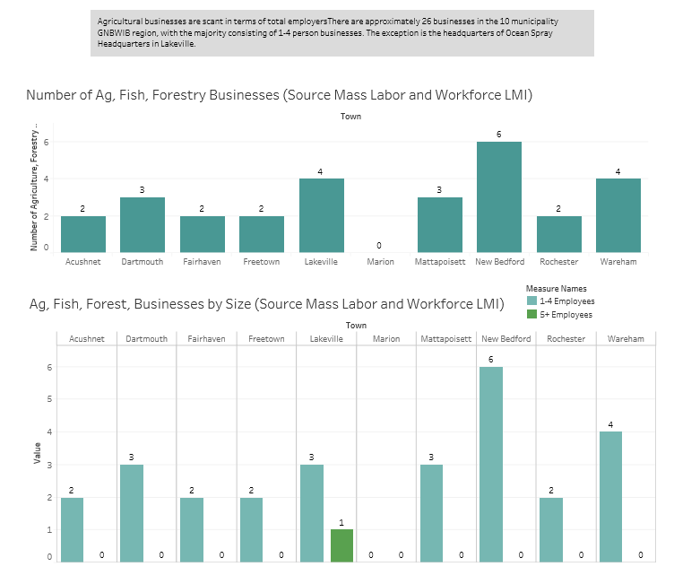
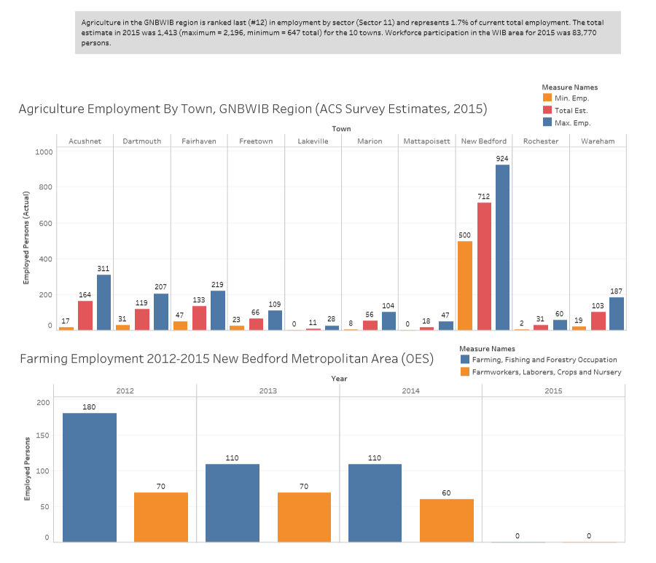

EMPLOYER ENGAGEMENT
The Local Board assures that it will lead efforts to engage with a diverse range of employers and with entities in the region that involve;
Promote business representation (particularly representatives with optimal policymaking or hiring authority from employers whose employment opportunities reflect existing and emerging employment opportunities in the region) on the local board
Develop effective linkages (including the use of intermediaries) with employers in the region to support employer utilization of the local workforce development system and to support local workforce investment activities
Ensure that workforce investment activities meet the needs of employers and support economic growth in the region, by enhancing communication, coordination, and collaboration among employers, economic development entities, and service providers
Develop and implement proven or promising strategies for meeting the employment and skill needs of workers and employers (such as the establishment of industry and sector partnerships), that provide the skilled workforce needed by employers in the region, and that expand employment and career advancement opportunities for workforce development system participants in in-demand industry sectors or occupations
In order to help current and future regional employers maintain existing jobs and create new ones, the Workforce Board ensures that employers are aware of the “Workforce Training Fund Program” (WFTP). This fund is specifically designed to help organizations offset the cost of training current and new employees. The WTFP targets smaller employers since it serves only incumbent workers employed by businesses with fewer than 100 workers. The Workforce Board holds annual WTFP Informational Sessions partnering with our Chamber, Economic Development Council and Community College to cast a wide-net of interested employers. Other training grants are also shared i.e. Small Business Direct Access, Express and Safety.
Another example is the Board’s key role in establishing sector partnerships in the manufacturing and healthcare industries. This is a collaborative effort between community organizations, community colleges, and employers. Board staff and partners are currently recruiting businesses and other important players to provide employers an opportunity to discuss their specific needs and then work toward training alignment to meet those needs.
As mentioned in other sections, the Board coordinates services to the business sector by assigning certain responsibilities to our Business Service Representatives (BSR) located in our MassHire Greater New Bedford Career Center, while retaining other responsibilities at the Board level. BSRs under the direction of The Workplace and the Division of Career Services focus on those services related to hiring, assessment, job matching, job referral, job requirements, job postings and assistance related to immediate needs of the business such as prevailing wage rates and screening.
The Board’s business service function encompasses industry sectors; economic development; connecting businesses with other businesses, education or economic development; labor market trends; business development; workforce intelligence; and projected skill needs.
The Board’s Chief Executive and Operating Officers meet regularly with the Lead Operator and MassHire Greater New Bedford Career Center Management staff to discuss any issues identified as a result of their interaction with employers and to provide information on emerging issues, events and activities resulting from the Board’s interaction with economic development, business associations, businesses, and/or other community agencies and leaders. These meetings also incorporate a degree of accountability to ensure the BSRs are meeting the needs of local employers.

COORDINATION WITH REGIONAL ECONOMIC DEVELOPMENT
The workforce board researches and applies for grants that promote entrepreneurial growth for residence looking to start businesses in the Greater New Bedford area particularly women. The board also partners and collaborates with the several existing organizations to promote entrepreneurial skills training and microenterprise services e.g.
The Board was awarded a grant for WEB New Bedford 2018 (WomEntrepreneurship and Business) through the Executive Office of Housing and Economic Development. WEB New Bedford (the WomEntrepreneurship and Business New Bedford) is a pilot 8-month accelerator cohort program providing education and networking for New Bedford residents to help start or grow their business. WEB is multi-partner collaborative effort to aggregate and provide comprehensive entrepreneurship education and business assistance to women, minorities.

The workforce board partners actively with Entrepreneurship for All (EforAll) which is accelerating economic and social impact through entrepreneurship in mid-sized cities. EforAll believes that the best way to revitalize mid- sized U.S. cities that have fallen into decline, and suffer related high rates of poverty and unemployment, is to fuel the dreams and ambitions of entrepreneurs who live in and near these cities. As well, they believe the offering inclusive entrepreneurship could help creating the pathway out of poverty. At EforAll, has developed an innovative small business/nonprofit accelerator to foster entrepreneurial growth and celebrate entrepreneurship into the local culture using pitch contests and other public events. Prepare entrepreneurs for the many responsibilities they will face, using our year-long accelerator program that starts with a 12-week intensive session.

The board actively supports and the executive director of the Community Economic Development Center of Southeastern Massachusetts, Inc. (CEDC) sits on the board of directors. The CEDC was founded in May of 1997 as a Community Development Corporation in the City of New Bedford. CDC’s are vital building blocks for community revitalization through innovative community-based economic development programs and affordable housing targeted to low and moderate income members of local communities. CEDC is no exception, as our efforts have served thousands of area residents left out of the economic mainstream. CEDC fosters economic justice in the local economy through people-centered development. We connect youth and adults to skill-building opportunities, and resources and we build community networks and collaborations to promote cooperative action for social change.

The workforce board actively engages with and works collaboratively with the Economic Development Council. The mission of the New Bedford Economic Development Council (NBEDC) is to work collaboratively to promote a transparent, business-friendly environment for sustainable job growth and increased private sector investment. The NBEDC continues to actively market the gateway city of New Bedford worldwide, as a top location for business growth and expansion, while remaining committed to assisting local companies and entrepreneurs with their start-up, expansion, and other business concerns. To accomplish this mission, the NBEDC established a strategy in 2007 that is rooted in our balanced and aggressive approach to support existing business, attract emerging industries, communicate a positive message, develop strategic sites, prepare a ready workforce, and capture long-term catalytic opportunities for growth. As a certified CDFI, an SBA Intermediary Microlender and an EDA lender, the NBEDC offers training, technical assistance, and loans to the city’s disadvantaged small businesses and entrepreneurs.

The workforce board staff also engages with several other organizations to support economic development in the region including SRPEDD, SEED, MSBDC, Interise, SCORE, CoCreative and local economic development departments.

MASSHIRE GREATER NEW BEDFORD CAREER CENTER SYSTEM
The Board will insure continuous improvement of eligible providers by working closely with the MassHire Greater New Bedford Career Center as well as, reaching out to local business, workers and job seekers through MassHire Workforce Board members, local chambers of commerce, economic development boards and local city government.
To insure, that resources, opportunities for training and job development for youth, the Workforce Board will continue oversight working closely with Youth Services department of the MassHire Greater New Bedford Career Center. The Workforce Board and the Youth Services Department of GNBCC, further, will work with all 10 High Schools in the region, insuring cooperation, partner development, and receive the services needed for in-school youth. Working face to face with local business organizations, local industry committees, boards and organizations the Board Insures the resources are available as needed by the customers of our region. MassHire Greater New Bedford Career Center, this year, will strive to work closer and be part of the community, with local business, school’s districts, state and local government and non-profits in new ways and in new areas.
The MassHire Greater New Bedford Career Center will take three approaches to facilitating services across the entire system including remote areas:
Operate remote sites offering; Wareham, South End New Bedford and Lakeville
Career counseling services
RESEA counseling
Career Centers Service seminar
Workshops
New Technology
Distance learning for workshops and seminars
Slype and conference calls
Social Media
Offer services and information in other languages
Videos
YouTube
Printed and electronic forms
The center will follow all federal, state and local laws and protocols as described in WIOA section 188 and the Americans with Disabilities Act of 1990(42U.S.C. 12101 et seq.). The center is currently not in full compliance but is actively working on a plan to meet all applicable state, federal and local statues and requirements. The procedures and protocols will be followed in all three areas
Environment/Space: the center will be checked for compliance according to ADA guidelines. The center will review the environment and space this year to insure compliance. As well as respond to any of the needs a customer might request regarding their disability.
Technology/Equipment; the center will be checked for compliance according to ADA guidelines. The center will continue to stay abreast of new technologies for people with disabilities. The center will insure and make a commitment to customers with disabilities by having the most current equipment available.
Programs and Training; the center will be checked for compliance according to ADA guidelines. The center will continue to update the programs and training for staff twice a year to insure that all of the staff is aware and are competent in the area of service people with disabilities.

WORK WITH CORE PARTNERS
The Workforce Board, Career Center and Core Partners have worked together over a period of a year to agree upon a shared common vision and purpose that continues to build trust and openness and recognizes the value and contribution of all members also needs to exist. Additionally, shared and transparent decision-making processes extending the scope of influence over and involvement with other services and activities will prove essential to our partnership. Shared goals and aims, understood and accepted as being important by each partner, lead to improved coordination of policies, programs, and service delivery, and, ultimately, better outcomes.
During partner MOU monthly meetings explicit discussion regarding framework, culture, values, and the approach of partner organizations was the subject at hand. We were all in agreement that partners need to be clear about and understand their roles and responsibilities, defining who does what regarding delivery of activities. It was equally important to acknowledge the existence of separate organizational aims and objectives and their connection to jointly agreed aims and objectives.
At MOU monthly meetings we recognize and acknowledge the opportunity for learning experiences and sharing good practices. Our partnership is considered a work in progress, meaning that we agree to a range of success criteria regarding maintaining the partnerships. This is ensured through feedback that flows to and from the partners for consideration for revisions and partnership aims, objectives, and arrangements.

ADULT EMPLOYMENT AND TRAINING ACTIVITIES
WIOA title I formula funds allocated to local areas for adults and dislocated workers are used to provide career and training services through the one-stop delivery system. We determine the most appropriate mix of these services, but both types are available for eligible adults and dislocated workers. Different eligibility criteria apply for each type of services. See §§ 680.120, 680.130, and 680.210.
WIOA title I funds may be used to provide the additional services described in WIOA sec. 134(d), including:
Job seeker services, such as:
Customer support to enable individuals with barriers to employment (including individuals with disabilities) and veterans, to navigate among multiple services and activities;
Training programs for displaced homemakers and for individuals training for nontraditional employment (as defined in WIOA sec. 3(37) as occupations or fields of work in which individuals of one gender comprise less than 25 percent of the individuals so employed), in conjunction with programs operated in the local area;
Work support activities for low-wage workers, in coordination with one-stop partners, which will provide opportunities for these workers to retain or enhance employment. These activities may include any activities available under the WIOA adult and dislocated worker programs in coordination with activities and resources available through partner programs. These activities may be provided in a manner that enhances the worker's ability to participate, for example by providing them at nontraditional hours or providing on-site child care;
Supportive services, including needs-related payments, as described in subpart G of this part; and
Transitional jobs, as described in § 680.190, to individuals with barriers to employment who are chronically unemployed or have an inconsistent work history;
Coordination activities, such as:
Employment and training activities in coordination with child support enforcement activities, as well as child support services and assistance activities, of the State and local agencies carrying out part D of title IV of the Social Security Act ( 42 U.S.C. 651et seq.);
Employment and training activities in coordination with cooperative extension programs carried out by the Department of Agriculture;
Employment and training activities in coordination with activities to facilitate remote access to services provided through a one-stop delivery system, including facilitating access through the use of technology;
Improving coordination between workforce investment activities and economic development activities carried out within the local area involved, and to promote entrepreneurial skills training and microenterprise services;
Improving services and linkages between the local workforce development system (including the local one-stop delivery system) and employers, including small employers, in the local area;
Strengthening linkages between the one-stop delivery system and the unemployment insurance programs; and
Technical assistance for one-stop centers, partners, and eligible training providers (ETPs) on the provision of service to individuals with disabilities in local areas, including staff training and development, provision of outreach and intake assessments, service delivery, service coordination across providers and programs, and development of performance accountability measures;
Activities to adjust the economic self-sufficiency standards referred to in WIOA sec. 134(a)(3)(A)(xii) for local factors or activities to adopt, calculate or commission for approval, economic self-sufficiency standards for the local areas that specify the income needs of families, by family size, the number and ages of children in the family, and sub-State geographical considerations;
Implementing promising service to workers and businesses, which may include support for education, training, skill upgrading, and statewide networking for employees to become workplace learning advisors and maintain proficiency in carrying out the activities associated with such advising.

RAPID RESPONSE
We will plan for and respond to a company notice of closure (WARN) within 48 hours following an event by partnering with our local Rapid Response Unit and our local Coordinator. The Workforce Board releases a Communication to all relevant partners with urgency regarding the designated person for the press. We ensure the delivery of services to enable dislocated workers to transition to new employment as quickly as possible. Our goal is to promote economic recovery by developing an ongoing and comprehensive approach to identify and prevent or minimize the impact on the workers as well as the businesses and the community. We will convene, broker and facilitate connections, networks and partners to ensure the ability to provide assistance to dislocated workers and their families such as heating assistance, legal aid and financial advice.
The Coordinator provides the appropriate notification and organizes a response team, including MassHire Greater New Bedford Career Center staff, to provide the following services, as applicable, to the employer and affected workers:
Immediate and on-site contact with the employer to the extent practical or allowed by the employer as well as representatives of the affected workers, and the local community
Guidance and/or financial assistance to establish a labor-management committee voluntarily agreed to by labor and management, or a workforce transition committee comprising representatives of the employer, the affected workers, and the local community that devises and oversees an implementation strategy to respond to the reemployment needs of affected workers
Emergency assistance adapted to the particular closing, layoff, or disaster
Development of a coordinated response to the dislocation event
State economic development assistance, as needed
An orientation on available workforce program services
Information on and assistance with filing for unemployment insurance (UI) benefits
Information on Trade services
Surveys the affected workers’ employment, knowledge, skills, and abilities
Other services offered, such as workshops and seminars on tools that will assist with a rapid transition to new employment
More importantly, the workforce board will assist in the coordinated response to the dislocation event and when necessary obtain access to State and local economic development assistance to possibly include the development of an application for a National dislocated worker grant.

INDIVIDUAL WITH DISABILITIES
Youth populations represent the future workforce and a key element of a thriving local economy. Through the youth program administered by us though the MassHire Greater New Bedford Career Center, customers are able to take advantage of an array of different activities designed to prepare them for the world of work. Youth can take advantage of many of the same offerings available to other populations such as staff assisted job search, workshops, assessment, short-term educational training, work readiness skills training, on-the-job training and secondary education equivalency services. One of the main components of the youth program is work experience, which allows youth, many of whom have never been exposed to employment, the opportunity to get practical hands on work experience while gaining valuable skills. For youth who are basic skills deficient, Workforce Center staff work with them to improve literacy and numeracy skills through a variety of computer based remediation exercises designed to refresh and improve reading comprehension and mathematical computation.
We have many career related assessments for our youth population that includes youth with disabilities. We feel that all youth benefit in participation in assessments of their prior work experience, employability, aptitudes and other interests. We offer multiple assessment tools depending on the youth’s preferences, motivations and skills since all factors tend to affect their potential success and interest of different career options. In order for youth to properly evaluate their employment options we educate them by providing reliable information about local and regional labor market on jobs that will provide living wages. The labor market information shared with them also includes the education and entry requirements. For youth with disabilities we provide information on workplace supports e.g. assistive technology and other accommodations.
YOUTH
These types of assessments are typically provided directly through WIOA youth program staff and many times through referrals from our MOU partners e.g. Department of Transitional Assistance, Massachusetts Rehabilitation Commission, and Massachusetts Commission for the Blind as well as other community based partners and resources.
Youth that are between the ages of 18 to 20 however could be assessed differently since they could participate in both WIOA Title 1 adult and youth programs concurrently. The best mix of services under youth and adult programs must be determined by our local program operators for these individuals. The school status at the time of enrollment will determine which program options will be appropriate for this population since young adults who are in school of course are only eligible for the Title 1 youth program if 21 or younger at the time of enrollment. During an assessment, if it is concluded that the young adult’s needs can be met by co-enrollment in WIOA Title 1 youth and adult programs the program operator needs to track the funding streams that pay for the cost and ensure that there will be no duplication of services.
We collaborate on and manage a number of different youth programs and activities throughout the year to help youth populations to find jobs/ learn about jobs, get remedial training, stay active in the summer and so much more.
Signaling Success is a program that includes three components designed to lead out-of-school youth 16-24 to occupational certification and long-term private sector employment. The contractor is typically the MassHire Greater New Bedford Career Center lead operator. Youth participants may be youth who are currently enrolled or new youth who are seeking occupational certification and private sector employment. Eligible youth will first complete a one week, 20 hour pre-employment t raining (Signaling Success). After successfully completing participants move to another week of 20 hour customer service training followed by the National Retail Federation customer service exam; leading to a nationally recognized credential in customer service. Youth who successfully complete both training programs will be placed i n a six-week subsidized work placement with a private sector employer who has agreed to hire youth who are successful in placement.
The Greater New Bedford Area YouthWorks Summer Jobs Program - YouthWorks is a Commonwealth-wide employment program that helps teens and young adults get the skills and experience needed to find and keep jobs.
Amp It Up! College Credit & Career Tours FY18 Program - A joint partnership between Wareham Public Schools and the Greater New Bedford Workforce Investment Board. The Spring and Summer 2018 program for 20 Wareham High School students includes:
One 3-credit early college dual enrollment course CAD 101 through Bristol Community College
At least 5 advanced manufacturing employer tours including Factory Five Racing, Titleist, Lockheed Martin and Five Star Manufacturing
Students earn college credits in an advanced manufacturing discipline course, tour and meet with advanced manufacturing employers in the area and are exposed to innovative partnerships to careers in advanced manufacturing.
Southeast Cyber Security -20 high school juniors and seniors from the Southeastern Massachusetts workforce region will complete a 15-month Cyber Security program, South East Cyber Sec. The students will earn a 22-credit Certificate in Cyber Security from Bristol Community College, CompTIA Network+ and Security+, complete a 140-hour co-op with a cybersecurity related employer, and receive career readiness skills to be entry-level job ready at completion of the program and at the time of their graduation from high school.
Mass Cultural Council - Partially fund the Artists Exhibit and Talk at the Groundwork! Gallery located at the Quest Center for Innovation in New Bedford. Since 2016, Groundwork Co-working has exhibited 26 artists in the public space on the ground floor of the Quest Center. These exhibits have also been paired with openings and artist talks which are open free to the community. Additionally, Groundwork! Gallery has been an AHA! Location since January 2018 and is open for free to the community. The artists on exhibit are primarily South Coast residents.
One of the target audiences is school aged children who will be selected by methodically contacting and collaborating with art teachers in each school. For example, we are interested in primary art teachers in the district to initiate conversations on showing student art work through a show at the Groundwork! Gallery. We would also like the artists to share both their creative process and share career advice and perspective with the school age children about the field during a special field trip to the space.

YOUTH COORDINATION WITH PARTNERS
Partners agree and assurances are incorporated into our local Umbrella MOU with the above entities that the workforce board and the career center will conduct activities relating to youth to share customers between partners with a clear understanding of how we as multiple providers of services and resources will support youth.
We have re-designed the MassHire Greater New Bedford Career Center customer flow and service practices across partner agencies, including ensuring the accessibility and availability of services to our shared youth customers in an effort to streamline duplicity. We all agree to utilize robust technology tools to scale-up practices and provide more significant supports for youth individuals with barriers to employment, including basic skills assessment, remediation, and career development tools; and to track and evaluate outcomes for the youth population. Together we have developed career pathways processes and systems for Youth 16-24 as well as youth with disabilities who qualify as a shared customer.
All Partners agree to prioritize services as outlined under WIOA. Under WIOA, the term ‘‘individual with a barrier to employment’’ is defined, but not limited to, a member of one or more of the following populations:
Individuals with disabilities, including youth who are individuals with disabilities
Homeless individuals or homeless children and youth
Youth who are in or have aged out of the foster care system
For youth who are basic skills deficient, staff members work with the youth to improve literacy and numeracy skills through a variety of computer based remediation exercises designed to refresh and improve reading comprehension and mathematical computation. The MassHire Greater New Bedford Career Center host specialized workshops, specifically for youth to address issues unique to the population, such as financial preparedness and planning for the future based on desired outcomes and realistic expectations. The Board is a proponent of inclusion; youth with disabilities can participate in all of the activities available to all youth. When necessary, MA Rehabilitation Commission (MRC) may be consulted to offer assistance if accommodations are needed, but it is of great importance that all youth are included, regardless of their disability status. Occupational and vocational training services are also available to youth. Youth may choose the same trainings available to Adults and Dislocated Workers.
Partners commit to offering priority for services within the parameters of their operations to recipients of public assistance, other low-income individuals, youth with disabilities or individuals who are basic-skills deficient, when providing individualized career services and training services with WIOA Adult funds. Priority of service status is established at the time of eligibility determination and does not change during the period of participation.
Partners also agree to maintain regular communication and interaction via face to face meetings at the MassHire Greater New Bedford Career Centers and via email and/or telephone to ensure collaboration in the development of strategies to support career pathways for individuals with disabilities, including students and youth with disabilities, to enter and retain employment and to support appropriate cross agency referrals. We work collaboratively to identify consumers with disabilities who are appropriate for job driven training and employment opportunities offered by workforce development/career centers. The workforce board ensures access to career center space for informational sessions, meetings with potential or shared consumers and “job driven” training initiatives, as appropriate. As part of our on-going strategy, we provide annual input and feedback as part of the process of the required assessment of physical and programmatic access of One-Stop Career Centers for people with disabilities.

COORDINATION OF SECONDARY AND POST SECONDARY PROGRAMS WITH TRAINING
The MassHire Greater New Bedford Workforce Board actively coordinates activities with education and training providers in the local area to develop and implement career pathways within the local area by aligning the employment, training, education, and supportive services that are needed by adults and youth, particularly individuals with barriers to employment.
The Southeast region is served by two community colleges; Bristol and Massasoit Community College and ten 4 year colleges and universities, Bridgewater State, Curry College, Eastern Nazarene, Laboure College, Massachusetts Maritime Academy, Stonehill College, Tabor Academy, UMass Dartmouth UMass Law and Wheaton College. The partnerships with the institutions are vital in providing opportunities for customers. Working closely with each group ensures enhancement of services and that any duplication of services is kept to a minimum. The community colleges offer workforce education certificate programs designed to provide specific skills for students so they may seek immediate employment. Students who complete certificate programs may also have the option to continue their career pathway by working towards an associate degree and receiving credit for studies they have completed. The university offers career pathway programs through articulation agreements with the regions community colleges.

WIOA AND SUPPORT SERVICES
The Board contracts with The Workplace to administer workforce programs, including WIOA Title I workforce investment activities that provide support services to their customers. These programs are governed by federal and state guidance. In addition, the Board maintains local policies that provide minimum standards and promote safeguards against the misuse of funds. The Board’s policy contains provisions that set documentation requirements and other parameters in the provision of support services for all workforce programs. It also sets parameters for the provision of specific types of support services, including transportation, basic needs assistance, work-related expenses, and other types of assistance as applicable to the various funding streams.

WAGNER PEYSER COORDINATION
The strategic plan implemented by our board and carried out by The Workplace includes an approach for implementing a customer-centric service delivery model, which will assess current customer flow and identifies opportunities for improvement. Monthly partner meetings are conducted for staff to discuss team-based service delivery, best practices, and challenges. Wagner-Peyser staff is located in the New Bedford Career Center and the collaborative working environment provides the opportunity to coordinate activities and avoid duplication.

MIGRANT SEASONAL FARM WORKERS
The Local Board assures that the local One-Stop Career Center (OSCC) Operators will ensure (in accordance with all relevant state policies and procedures and as required under 20 CFR Part 651, Definitions; Part 652, Subpart C; Part 653, Subpart B and F; Part 654, Subpart E; Part 658, Subpart E and Subpart F; Part 678, Subpart B and Part 685, Subpart B that Migrant and Seasonal Farm Workers (MSFWs) will receive the full array of workforce development services, benefits and protections on a non-discriminatory manner and that the services provided to MSFWs will be “qualitatively equivalent and quantitatively proportionate” to the services provided to other jobseekers.
OSCC will identify and register Migrant and Seasonal Farmworkers (MSFWs); provide such customers - including those English Language Learners (ELLs) - with services and information to include assessment of skill levels and abilities, career guidance, job search workshops, referral to jobs or training as appropriate, workers’ rights and complaint system information. The services offered to employers, in addition to referral of job seekers in response job openings, include matching job requirements with job seeker experience, skills and other characteristics, assisting employers with hard-to-fill job orders and other workforce development services as needed. Conduct appropriate follow-up with employers, applicants and other service providers; and report all relevant activities through MOSES and any other ad-hoc required reports. Workforce Development Boards / One-Stop Career Centers will continue to integrate, coordinate, develop, and implement systems and strategies to better serve the agricultural community.
All CC staff is trained on how to administer services to MSFWs and their families by the Department of Career Services. CC staff are required and trained to ensure that the services provided to Farmworkers (and their families) – whether seasonal or migrant are “qualitatively equivalent and quantitatively proportionate” to the services provided to other jobseekers and that all workforce development services, benefits and protections are received on an equitable and non- discriminatory basis.
CC staff is trained to provide adequate staff assistance to each MSFW to use the Resource Room and for the use job order information and services effectively.
- Local office staff is required to determine whether an applicant is a MSFW at the time of the first interview, as defined by 20 CFR 651.10 using the MSFW Desk Aid.
- Applicant completes application/registration (membership) Job specialist reviews information with the applicant for completeness/accuracy
- Asks pertinent questions regarding demographics, employment history, education, skills and employment goals
- Completes registration process in MOSES
- In addition, all business services should be extended to agricultural employers
- Agricultural employers can benefit from WOTC, trade, veterans, bonding programs, job order / recruitment services
- Agriculture Outreach / BSRs staffs should act as a “portable OSCC” for employers as well as for workers
- Provide assistance / information to agricultural employers about labor laws and regulations affecting them

ALIGNMENT OF TITLE I AND TITLE II
In compliance with the state requirement to include workforce investment activities with adult education and literacy activities under WIOA Title II, The Workplace provides a dedicated space for the ABE/GED provider in the New Bedford Career Center. The strategic plan includes action steps that will engage both employers and education partners in the development of a "life skills" curriculum to create a seamless connection to training programs. The ABLE/GED provider addresses both the adult education and literacy activities of WIOA Title II and is part of a pathway to training and career development.
Each eligible provider desiring a grant or contract from an eligible agency shall submit an application to the eligible agency containing such information and assurances as required.

INCREASING PARTNERSHIPS
In FY19, a key partnership goal was to expand youth services to all 10 municipalities in the Greater New Bedford region. This was achieved in partnership with the Connecting Activities grant administered by the workforce board with work undertaken jointly by the South Coast Chamber of Commerce and the MassHire Greater New Bedford Career Center. As of October 2018, all high schools in the region had signed agreements expanding significantly the youth partnerships for the region.
The workforce board will also adhere to the statewide collaborative agreement in place between DCS and the New England Farm Workers’ Council (NEFWC), the WIOA Sec. 167 Grantee as listed in the consolidated Commonwealth Plan.

FISCAL AGENT CONTACT INFO
The fiscal agent is the workforce board. The contact is Dr. Kaisa Holloway Cripps, Chief Operating Officer, Quest Center for Innovation, 1213 Purchase Street, New Bedford, MA 02740. 508.979.1504. kaisa@masshiregreaternewbedford.com

COMPETITIVE REWARDS PROCESS
The workforce board adheres to all applicable federal, state, and local requirements for procurement of goods and services including, but not limited to 2 CFR 200 and 100 DCS 01.102

LOCAL LEVELS OF PERFORMANCE FY19
SUMMARY | July-June FY2016 | July-June FY2017 | July-April FY2018 | Planned  FY2019
A. Job Seekers Services
1. Total Job Seekers Served | 6,234 | 5,667 | 4,046 | 4,800
a. Total Job Seekers Unemployed | 5,733 | 887 | 3,730 | 4,320
b. Persons with Disabilities | 346 | 341 | 256 | 202
c. UI Claimants Served | 3,000 | 2,877 | 2,127 | 3,840
d. Veterans Served | 312 | 304 | 200 | 288
B. Employer Services
1.Total Employers Served (= 1.a + 1.b) |  | 336 | 368 | 460
a. New to Career Center |  | 260 | 140 | 175
b. Repeat |  | 76 | 228 | 285
2. Employers Receiving Job Seeker Referrals |  | 185 | 184 | 350
3. Employers Hiring from Referrals |  | 31 | 37 | 200

DISLOCATED WORKER PROGRAM | Formula  Carry-in  from FY2018 | Formula  New in  FY2019 | FY2019  TOTAL
1. Participants | 66 | 90 | 156
2. Program Exiters (= 2.a + 2.b) | 40 | 40 | 80
a. Enter Employment |  |  | 64
i. Average Hourly Wage at Placement |  |  | $15.55
b. Other Exit Reasons |  |  | 16
3. Carry-Out to FY2020 (= 1 - 2) |  |  | 76
4. Entered Employment Rate at Exit (= 2.a / 2) |  |  | 80%
5. Total Participants in Training Activities (single count*) | 35 | 37 | 72
a. Basic Education / Literacy Skills | 2 | 2 | 4
b. ESOL (ESL) | 12 | 12 | 24
c. Occupational Skills Training (all including ITA) | 15 | 27 | 42
i. Occupational Skills Training (Customized) | 10 | 10 | 20
ii. Occupational Skills Training (Group Contracts) | 5 | 2 | 7
d. On-the-Job Training (OJT) | 0 | 3 | 3
6. Training Participants Obtaining Certificate/Credential | 15 | 28 | 43
7. Support Services | 15 | 10 | 25
a. Needs Based Payments | 0 | 4 | 4

YOUTH PROGRAM | In School Youth |  | Out of School Youth |  | FY2019  TOTAL
1. Participants (= 1.a + 1.b) | 20 |  | 95 |  | 115
a. New Enrollments during FY2019 | 20 |  | 73 |  | 93
b. Carry-Overs from FY2018 | 0 |  | 22 |  | 22
c. Youth Age 14 – 15 | 0 |  | 0 |  | 0
d. Youth Age 16 – 18 | 23 |  | 57 |  | 80
e. Youth Age 19 – 21 | 0 |  | 34 |  | 34
f. Youth Age 22 – 24 | 0 |  | 9 |  | 9
2. Program Exiters (= 2.a+2.b+2.c) | 20 |  | 69 |  | 89
a. Enter Employment | 3 |  | 20 |  | 23
b. Enter Post-Secondary Education or Training | 13 |  | 35 |  | 48
c. Other Exit Reasons | 4 |  | 14 |  | 18
3. Carry-Out to FY2020 (formula = 1 - 2) | 0 |  | 26 |  | 26
4. Employment or Education Rate (= (2.a + 2.b) / (2)) | 80% |  | 80% |  | 80%
5. Enrollments by Fourteen Program Elements
a. Tutoring and Dropout Prevention | 15 |  | 0 |  | 15
b. Alternative Secondary School, HiSET Prep, ESOL | 0 |  | 75 |  | 75
c. Work Experience, Internships, OJT, Summer Empl Op | 15 |  | 80 |  | 95
d. Occupational Skills Training | 0 |  | 60 |  | 60
e. Leadership Development Opportunities | 15 |  | 40 |  | 55
f. Adult Mentoring | 15 |  | 95 |  | 110
g. Comprehensive Guidance and Counseling | 15 |  | 95 |  | 110
h. Education Concurrently w/ Workforce Prep | 15 |  | 60 |  | 75
i. Entrepreneurial Skills Training | 0 |  | 2 |  | 2
j. Financial Literacy Education | 15 |  | 95 |  | 110
k. Post Sec Education/Training Transition Activities | 10 |  | 80 |  | 90
l. Labor Market/Employment Information Services | 0 |  | 95 |  | 95
m. Supportive Services | 0 |  | 79 |  | 79
n. Follow-up Services | 0 |  | 89 |  | 89
6. Attained Degree/Diploma/HiSET/Certificate | 16 |  | 55 |  | 71
7. Attained Degree/Diploma/HiSET/Certificate Rate(= 6/2) | 80% |  | 80% |  | 80%
ADULTS |  | Formula  Carry-in  from FY2018 |  | Formula  New in  FY2019 |  | FY2019  TOTAL
1. Participants |  | 62 |  | 34 |  | 96
2. Program Exiters (= 2.a + 2.b) |  | 38 |  | 28 |  | 66
a. Enter Employment |  |  |  |  |  | 55
i. Average Hourly Wage at Placement |  |  |  |  |  | $12.63
b. Other Exit Reasons |  |  |  |  |  | 11
3. Carry-Out to FY2020 (= 1 - 2) |  |  |  |  |  | 30
4. Entered Employment Rate at Exit (= 2.a / 2) |  |  |  |  |  | 83%
5. Total Participants in Training Activities (single count*) |  | 15 |  | 27 |  | 42
a. Basic Education / Literacy Skills |  | 2 |  | 2 |  | 4
b. ESOL (ESL) |  | 7 |  | 5 |  | 12
c. Occupational Skills Training (all including ITA) |  | 11 |  | 11 |  | 22
i. Occupational Skills Training (Customized) |  | 10 |  | 10 |  | 20
ii. Occupational Skills Training (Group Contracts) |  | 2 |  | 0 |  | 2
d. On-the-Job Training (OJT) |  | 0 |  | 3 |  | 3
6. Training Participants Obtaining Certificate/Credential |  | 37 |  | 28 |  | 65
7. Support Services |  | 16 |  | 10 |  | 26
a. Needs Based Payments |  | 0 |  | 4 |  | 4

HIGH PERFORMANCE WORKFORCE BOARD
MassHire Greater New Bedford Workforce Development Board will take the following actions to maintain our status as a high performing board. These steps and actions support and align with our goals, strategies, and actions of the MassHire Greater New Bedford Workforce Board Strategic Plan.
- Focus on implementing, monitoring, and updating the MassHire Greater New Bedford Workforce Development Board Strategic Plan
- Frame the MassHire Greater New Bedford Workforce Development Board meetings around strategic initiatives and utilize a consent agenda
- Continue and maintain development of comprehensive talent attraction, development, and retention strategy for the region and prepare a pipeline of work-ready individuals based upon the needs of employers
- Continue to encourage innovation
- Maintain and establish the MassHire Greater New Bedford Workforce Development Board as the central hub for workforce development activities and be positioned as the “go to” source for labor market information and use that intelligence for decision making
- Continue to be business-driven and use a sector-based approach to engaging regional employers
- Be diverse and a reflection of the community
- Progress track the effectiveness of initiatives and customer satisfaction and adjust accordingly
- Continue to include community members on committees implementing of our strategic plans
- Continue to learn and understand how to build on partner strengths to align services and leverage resources for a common regional agenda

BOARD DIRECTOR TRAINING
All Board Directors receive training from the MassHire Workforce Board’s CEO. This training usually takes place at the MassHire Greater New Bedford Career Center with CC management present so that members get a good sense of the environment first hand and are able to ask questions. A tour of the MassHire Greater New Bedford Career Center is made available to the new directors. New director board orientation is provided using a power point which includes key contents of knowledge that is expounded upon by a robust conversation. WIOA is a cumbersome legislation but we are following it anyways because we all like our jobs for the most part. Conversations around these main topics occur during this initiation; our mission, vision and values, The workforce board and workforce area, super region history, the MassHire story, WIOA and the three pillars of WIOA, WIOA core programs, what boards do, how they as boards directors are able to help, all about board composition, what the staff does, all bout MassHire Greater New Bedford Career Center and our lead operator, current board committees and structure and staff contacts.

BOARD DIRECTORS IN PRIVATE BUSINESS
A board director’s main role is to serve as a voting director who is vested responsibility for strategic planning, governance, policy-making and performance evaluation.
As active board members their responsibilities include that they:
- Attend and participate constructively in all full meetings (not less than 3 meetings per year).
- Attend and participate in board retreats, Working Groups, planning meetings, workshops and other board development activities.
- Stay informed about mission, policies, and programs, and become informed about your legal responsibilities, such as conflict of interest laws, and duties as a member of the Board, i.e.: Seek to review committee minutes as posted on website.
- Serve as a year-round representative and in the on-going task of member retention and membership growth.
- Help develop and monitor the implementation of short and long-term strategic plans.
- Avoid any conflict of interest or appearance of conflict and immediately disclose any potential or actual conflict of interest to the Chair or Executive Director/CEO.
- Maintain the confidence of the board at all times.

BOARD SUPPORT OF BUSINESS SERVICES
All board members are encouraged to register with the MassHire Greater New Bedford Career Center and utilize all available resources i.e. MA BizWorks, Job Quest, arrange individual career day fairs, contribute to placement of trained job seekers and be active supporters of speed interview programs. Board directors learn first-hand the challenges of employers to remain competitive and job seekers to obtain meaningful employment throughout all ten communities that we directly serve. As a business representative a board director must:
- Be an owner, CEO, COO or other individual with optimum policymaking or hiring authority; 2) provide employment opportunities in in-demand industry sectors or occupations, as those terms are defined in WIOA Section 3(23)
- Provide high-quality, work-relevant training and development opportunities to its workforce or the workforce of others (in the case of organizations representing business as per WIOA Section 107(b)(2)(A)(ii)
- Be appointed from among individuals nominated by local business organizations and business trade associations

TRAINING SERVICES AND INDIVIDUAL TRAINING ACCOUNTS
Including if contracts for training services will be used, how the use of such contracts will be coordinated with the use of individual training accounts under that chapter, and how your Board will ensure informed customer choice in the selection of training programs regardless of how the training services are to be provided.
The MassHire Greater New Bedford Career Center under the direction of The Workplace works with individuals to provide them with an individual training plan. Individuals complete an assessment to determine program eligibility, are provided a demand occupation list, a list of approved training providers, and information to guide them to the state website for additional useful information.
ITA’s have a cap established and voted by the Board. The Cap is $3,500 for fiscal year 2019.
The cap may be exceeded with written approval of Executive Director after review of training selection sheet. National Dislocated Worker Grants, Rapid Response Grants, NEG’s and other grants are not subject to the standard cap for WIOA funds.

WORK-BASED TRAINING MODELS AND ON THE JOB TRAINING
The MassHire Greater New Bedford Workforce Board focuses on On-the-Job Training contracts when promoting as part of a specific program outside of the normal WIOA Adult and Dislocated Worker i.e. Traditional OJT is always available and an option for both employer and job seeker. OJTs can be used to off-set Apprenticeships. When the traditional training (usually ITAs) option is used, the Career Center Operator will follow the procedures established for the OJT/NEG local policy. When using an OJT model instituted by the State of Feds, the MassHire Greater New Bedford Workforce Boards SPOC and MassHire Greater New Bedford Career Center will work in concert with the Primary Operator in charge of a particular program.
Customized Training (WIOA Sec. 3(14) is another form of a training plan for job seekers that is designed to meet the specific requirements of an employer (or group of employers). The training is conducted with a commitment by the employer to employ an individual upon successful completion of the training for which the employer pays a significant portion of the cost of training, as determined by the local board, taking into account the size of the employer and other factors determined by the board and further defined in this part.

APPRENTICESHIP
The workforce board recognizes apprenticeships as a valid and reliable mechanism for career pathways in priority industry sectors in the region and local area. In 2018, the board appointed a representative of a pre-apprenticeship program to expand capacity and understanding of apprenticeship opportunities. The career center also hosted a pre-apprenticeship recruiting event as a first step in building apprenticeship opportunities in the region. The board has actively participated in webinars and training on understanding the development and appropriation of apprenticeships. The board actively engages with regional vocational schools such as Greater New Bedford Voc-Tech, Bristol County Agricultural High School and Old Colony Regional Vocational Technical High School which each offers career pathways and vocational shops engaged in apprenticeship fields. As part of the new grant in cybersecurity through the MassCyberCenter for 2018-2019, the board is also examining opportunities for apprenticeships in IT.

INCUMBENT WORKER TRAINING
Incumbent Worker Training WIOA funded training for incumbent workers is designed to meet the specific requirements of an employer (including a group of employers) to retain a skilled workforce or avert the need to lay off employees by assisting the workers in obtaining the skills necessary to retain employment and conducted with a commitment by the employer to retain or avert the layoff of the incumbent worker. Ideal incumbent worker training is where a participant acquires new skills allowing him or her to move into a higher skilled and higher paid job with the company, thus allowing the company to hire a job seeker to backfill the incumbent worker’s position. Incumbent worker training must increase both the participant’s and the company’s competitiveness. An incumbent worker does not necessarily have to meet the eligibility requirement for career and training services for adults and dislocated workers under WIOA (CFR 20 680.780). The Massachusetts Workforce Training Fund Program (the WTFP), provides cash grants to employers to support skills upgrading training programs for their employees. This resource is discussed with every employer when visited by either the MassHire Greater New Bedford Workforce Board or Career Center staff. It is part of the discussion when covering all resources MA offers through MA BizWorks.

WORKKEYS
The WorkKeys curriculum is used to verify attainment of foundational skills in combination with other services for career pathways, apprenticeships, or additional credentials. The curriculum is used for remediation for numeracy/literacy, as a screening tools for program/training placement, as a baseline skills assessment of basic workplace competencies mainly in these the competencies of Graphic Literacy, Workplace Documents, and Applied Math.

NATIONAL CAREER READINESS CURRICULUM (NCRC)
The Career Center utilizes the National Career Readiness Certificate (NCRC) knowing that these remediation tools can build customers’ skills and fund career credentialing services for Workforce Innovation Opportunity Act (WIOA) participants. More specifically, we know that the effort helps to increase the educational attainment of job seekers and provides them with the opportunity to secure fulfilling careers in sustainable industries. Typically, the three tools used are the Career Ready 101/WorkKeys Curriculum, WorkKeys 2.0, and the National Career Readiness Certificate (NCRC) which are all part of the ACT Workforce Solutions System.

PUBLIC COMMENT PERIOD
In accordance with WIOA regulations, the MassHire Greater New Bedford Workforce Board has provided for an up to 30-day public comment period prior to submission of the plan, including an opportunity to have input into the development of your local plan by representatives of businesses, education, and labor organizations. The workforce board has made available copies of a proposed local plan to the public through electronic means by posting at MassHireGreaterNewBedford.com
The workforce board has allowed the public to submit comments, not later than the end of the 30-day period beginning on the date on which the proposed local plan is made available, which is December 4, 2018. The workforce board shall include with the local plan submitted to the Governor any such comments that represent disagreement with the plan.
ASSURANCE FOR PRIORITY OF SERVICE
The MassHire local workforce board has adopted a local policy and process that ensures priority for adult career and training services is given to recipients of public assistance, other low-income individuals, and individuals who are basic skills deficient consistent with WIOA sec. 134(c) (3) (E), § 680.600 and 100 DCS 18.101.1 These include:
- Veterans and eligible spouses
- Recipients of public assistance
- Other low-income individuals
- Individuals who are basic skills deficient
The Local Board assures that One-Stop MassHire Greater New Bedford Career Center Operators will provide Career Planning services for targeted customers consistent with state policy. Customers targeted for career planning services include: WIOA Title I enrollees (priority shall be given to: recipients of public assistance, other low-income individuals, and individuals who are basic skills deficient); military “eligible covered persons” (Veterans and certain spouses of Veterans) Veterans who are between 18-24, service connected disabled Veterans and any Veteran with a significant barrier to employment in compliance with Guidance from DOL/VETS; National Dislocated Worker Grant (NDWG) participants; and Trade Adjustment Assistance (TAA) participants.

Appendix A - Operational Definitions of Performance Indicators
Six Primary Indicators of Performance | Detail (Operational Definition)
A. Employment Rate - 2nd Quarter After Exit  A-1. Title I Youth Education and Employment Rate - 2nd Quarter After Exit | The percentage of participants who are in unsubsidized employment during the second quarter after exit from the program (for title I Youth, the indicator is the percentage of participants in education or training activities, or in unsubsidized employment during the second quarter after exit)  The percentage of title I Youth program participants who are in education or training activities, or in unsubsidized employment, during the second quarter after exit from the program.
B. Employment Rate - 4th Quarter After Exit  B-1. Title I Youth Education and Employment Rate - 4th Quarter After Exit | The percentage of participants who are in unsubsidized employment during the fourth quarter after exit from the program (for title I Youth, the indicator is the percentage of participants in education or training activities, or in unsubsidized employment during the fourth quarter after exit)  The percentage of program participants who are in education or training activities, or in unsubsidized employment, during the fourth quarter after exit from the program.
C. Median Earnings - 2nd Quarter After Exit | The median earnings of participants who are in unsubsidized employment during the second quarter after exit from the program
D. Credential Attainment | The percentage of those participants enrolled in an education or training program (excluding those in on-the-job training (OJT) and customized training) who attain a recognized postsecondary credential or a secondary school diploma, or its recognized equivalent, during participation in or within one year after exit from the program. A participant who has attained a secondary school diploma or its recognized equivalent is included in the percentage of participants who have attained a secondary school diploma or its recognized equivalent only if the participant also is employed or is enrolled in an education or training program leading to a recognized postsecondary credential within one year after exit from the program
E. Measurable Skill Gains | The percentage of program participants who, during a program year, are in an education or training program that leads to a recognized postsecondary credential or employment and who are achieving measurable skill gains, defined as documented academic, technical, occupational, or other forms of progress, towards such a credential or employment. Depending on the type of education or training program, documented progress is defined as one of the following:  - Documented achievement of at least one educational functioning level of a participant who is receiving instruction below the postsecondary education level;  - Documented attainment of a secondary school diploma or its recognized equivalent;  - Secondary or postsecondary transcript or report card for a sufficient number of credit hours that shows a participant is meeting the State unit's academic standards;  - Satisfactory or better progress report, towards established milestones, such as completion of OJT or completion of one year of an apprenticeship program or similar milestones, from an employer or training provider who is providing training; or  - Successful passage of an exam that is required for a particular occupation or progress in attaining technical or occupational skills as evidenced by trade-related benchmarks such as knowledge-based exams.
F. Effectiveness in Serving Employers | Effectiveness in Serving Employers: WIOA sec. 116(b) (2) (A) (i) (VI) requires the Departments to establish a primary indicator of performance for effectiveness in serving employers. The Departments are piloting three approaches designed to gauge three critical workforce needs of the business community.  - Approach 1 - Retention with the same employer - addresses the programs' efforts to provide employers with skilled workers;  - Approach 2 - Repeat Business Customers - addresses the programs' efforts to provide quality engagement and services to employers and sectors and establish productive relationships with employers and sectors over extended periods of time; and  - Approach 3 - Employer Penetration Rate - addresses the programs' efforts to provide quality engagement and services to all employers and sectors within a State and local economy.  Since this indicator is a new approach for measuring performance under WIOA's six core programs, the Departments have implemented a pilot program during which States must select two of the three approaches to report data that the Departments will use to assess a permanent indicator. States may also voluntarily develop an additional State-specific approach. The Departments will evaluate State experiences with the various approaches and plan to identify a standardized indicator that the Departments anticipate will be implemented no later than the beginning of Program Year 2019.

Commonwealth Corporation/New England Public Policy Center of the Federal Reserve Bank of Boston, Labor Market Trends in the Southeast Region
UMASS Donahue Institute Report, Long-Term Population Projections for Massachusetts Regions and Municipalities,
http://lmi2.detma.org/Lmi/LTOCCprojections.asp
https://public.tableau.com/profile/greater.new.bedford.workforce.investment.board#!/vizhome/GNBWIBDashboardwagesMay2015/DashboardEmployeesbyOccupationGNBWIBArea2015FiltersbyTitleHourlyWageTotalEmployees
https://www.congress.gov/113/bills/hr803/BILLS-113hr803enr.pdf
https://www.congress.gov/113/bills/hr803/BILLS-113hr803enr.pdf
https://www.law.cornell.edu/cfr/text/20/678.430
https://www.law.cornell.edu/cfr/text/34/361.430
https://www.law.cornell.edu/cfr/text/34/463.430
https://www.law.cornell.edu/cfr/text/20/678.430
https://www.law.cornell.edu/cfr/text/34/361.430
https://www.law.cornell.edu/cfr/text/34/463.430
https://www.law.cornell.edu/cfr/text/34/463.34
https://www.congress.gov/113/bills/hr803/BILLS-113hr803enr.pdf
https://www.law.cornell.edu/cfr/text/20/part-681
https://www.law.cornell.edu/cfr/text/34/463.31
https://www.law.cornell.edu/cfr/text/34/463.35
https://www.law.cornell.edu/cfr/text/20/678.430
https://www.law.cornell.edu/cfr/text/34/361.430
https://www.law.cornell.edu/cfr/text/34/463.430
POS for Veterans: https://www.mass.gov/service-details/priority-of-service-for-veterans State Plan: https://www.mass.gov/files/documents/2018/02/09/ma-wioa-state-plan-final-4-7-16.pdf

