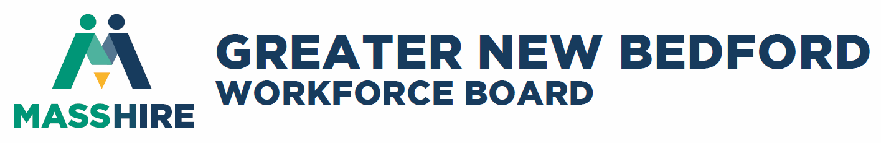

Quarterly Board Meeting
Thursday, September 26, 2019

Moby Dick Brewing Company
Located in: New Bedford Whaling National Historical Park
16 S Water St, New Bedford, MA 02740

Light Breakfast & Networking Opportunity at 7:30 a.m.
Meeting starts at 8 a.m.

Table of Contents

AGENDA FOR TODAY’S MEETING 3
INTRODUCTIONS AND ANNOUNCEMENTS 4
Please join me as we welcome six new Board Members: 4
Let’s also welcome a new Workforce Board employee: 4
Thank You Letter to the Workforce Board: 4
CONSENT AGENDA 6
June Minutes - Vote to approve 6
TREASURER’S REPORT – Vote to approve 7
MASSHIRE GNB WORKFORCE DEVELOPMENT BOARD BUSINESS 7
REPORTS 8
Executive Director Report 8
Performance and Oversight Committee 8
Business Development Committee 9
Youth Committee 9
CAREER CENTER UPDATES AND REPORTS 11
TEACHER EXTERNSHIP GUEST SPEAKER - ISAIAH HOUTMAN 13
FY20 MEETING SCHEDULE 18
ADJOURN 18

AGENDA FOR TODAY’S MEETING

GREETING AND CALL TO ORDER Dave Slutz, Chair
INTRODUCTIONS AND ANNOUNCEMENTS Dave Slutz, Chair
Introduce new Board Members
Introduce new Workforce Board employee
Letter to the MassHire Workforce Board from North Star Learning

CONSENT AGENDA Dave Slutz, Chair
- Minutes of Annual Meeting in June - Pages 4-10 (Vote required)
- Treasurer’s Report (Vote required)

BUSINESS
Two changes/revisions to plans & policies needing ratification by the Board

EXECUTIVE DIRECTOR REPORT Jim Oliveira, ED/CEO

REPORTS
- Performance & Oversight Committee Ron Melbourne, Chair
- Business Development Committee Rick Kidder, Chair
- Youth Council – Vote required Jeff Pelletier, Chair
- Career Center Operations James Daniels, Director

GUEST SPEAKER INTRODUCTION Jim Oliveira, ED/CEO

ADJOURN

INTRODUCTIONS AND ANNOUNCEMENTS

Please join me as we welcome six new Board Members:
Nelson Abreu, Director, Department of Transitional Assistance (DTA)
Rachel Gordon, Human Resource Manager, Precix, Inc.
Michael Hiltner, Human Resource Director, Acushnet Company
Lauren DeSimon Johnson, SVP & Chief Human Resources Director of SouthCoast Hospitals Group
Jennifer Patnaude, Chief Administrative Officer, Greater NB Community Health Center
Charles Quinn, Owner, East Coast Fabrication
Note: Published press release in the local newspapers to follow soon.

Let’s also welcome a new Workforce Board employee:
Jacqueline Sylvia, Website Developer
Jacqueline Sylvia joins MassHire as Website Developer after a long career in the private sector operating her own web development firm serving as owner/operator, marketing specialist, webmaster and designer. Jacqueline is a graduate of UMass Dartmouth with a B.S. in Marketing. Earlier in her career Jacqueline served as Marketing Communications Specialist for several organizations including Johnson & Johnson, Professional, Inc. In accepting the position, Jacqueline stated she was particularly attracted to MassHire’s goal of improving conditions for employers and our area’s workforce and looks forward to working with the team in a collaborative effort.
Note: Published press release in the local newspapers to follow soon.

Thank You Letter to the Workforce Board:
Megan Ryan, LCSW from NorthStar Learning Centers, Inc. sent a wonderful letter of gratitude to the Workforce Board stating, “Through your office supply donations, we have been able to partially furnish & decorate our community center and will soon be opening the doors to our participants, families and neighbors.”

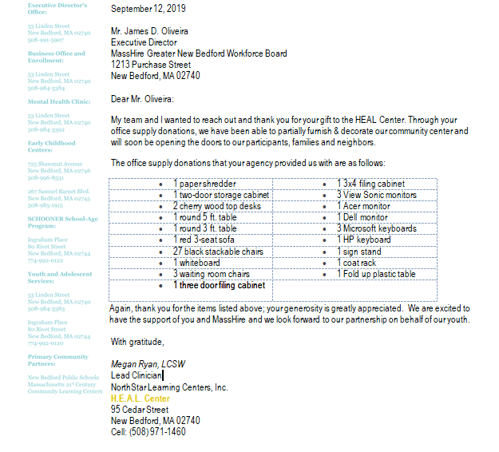

CONSENT AGENDA

June Minutes - Vote to approve

GREETING AND CALL TO ORDER - meeting called to order at 8:07
INTRODUCTIONS AND ANNOUNCEMENTS Dave Slutz, Chair
SOUP – NBHS 4 students, w/internships
CONSENT AGENDA Dave Slutz, Chair Minutes of April 2019 Quarterly Meeting - Pages 4-10 (Vote required)
  - Motion to approve made by R. Kidder, seconded by H.D. Hughes
- Treasurer’s Report (Vote required) Julie Rodriques, CFO
  - Motion to approve made by R. Kidder, seconded by H.D. Hughes

EXECUTIVE DIRECTOR REPORT Jim Oliveira, ED/CEO
FY17 – FY19 WIOA LOCAL PLAN (ppt)
FY20 Budget – Motion to approve made by J. Fernandes, seconded by R. Kidder, abstention by D. Hurley

ELECTION OF FY20 OFFICERS Rick Kidder, Nominating Chair
Election of officers approved, motion made by R. Kidder, seconded by J. Fernandes
Reappointments – motion made by H. D. Hughes, seconded by J. Fernandes

REPORTS
- Business Development Committee – Vote required Rick Kidder, Chair
  - Foundation Search – cost $8,995. Motion made by R. Kidder, seconded by J. Fernandes & H.D. Hughes
- Performance & Oversight Committee Ron Melbourne, Chair
  - Ron provided an update to the committee’s concerns and need to see better and more meaningful reports from the CC/TWP. Awaiting the results of several audits for review and discussion
- Youth Council – Vote required Jeff Pelletier, Chair
  - Jeff provided the committee member with the final awards for the four vendors for OOSY proposals
    - PACE & PAACA - $85K
    - EWorks - $75K
    - BIC - $60K
      - Motion made by R. Kidder and seconded by L. Douglas – abstention by P. Kuechler
GUEST SPEAKER The WorkPlace
Nestor shared a PPT of results over the past year

BUSINESS
- THE WORK PLACE CHARTER EXTENSION–Vote required Dave Slutz, Chair
- Motion to approve the charter for another year motion made by H.D. Hughes, seconded by L. Lemieux
- PTO REVISION TO THE MASSHIRE WORKFORCE BOARD
  - Motion made by H.D. Hughes to approve, seconded by J. Fernandes
EMPLOYEE MANUAL – Vote required
- PAID FAMILY & MEDICAL LEAVE LAW (PFML) PASSED – Vote required
  - Discussion for a 50/50 cost share - employee/board, total $528.99. Motion for approval made by L. Douglas, seconded by H. D. Hughes

CAREER CENTER OPERATIONS James Daniels, Director of the MassHire Career Center
OLD BUSINESS – Discussion ensued regarding the regionalization of workforce boards
D. Santos shared thought about the two-plan in regards to advanced robotics that will probably hit lower entry level positions first. Discussion regarding how the future of work will impact the local workforce ensued.
ADJOURN - meeting adjourned 9:21

TREASURER’S REPORT – Vote to approve – report available at the meeting

MASSHIRE GNB WORKFORCE DEVELOPMENT BOARD BUSINESS

Executive Committee suggestions to the Board of Director’s for ratification

- Increase the Standard Mileage Rates from 54.5 cents to 58 cents

IRS Releases 2019 Standard Mileage Rates
The Internal Revenue Service (IRS) released Notice 2019-02 providing the 2019 standard mileage rates. Beginning January 1, 2019, the standard mileage rates for the use of a car (vans, pickups or panel trucks) will be:
- 58 cents per mile for business miles driven, up from 54.5 cents for 2018
Notice 2019-02 contains the standard mileage rates, the amount taxpayers must use in calculating reductions to basis for depreciation taken under the business standard mileage rate, and the maximum standard automobile cost that may be used in computing the allowance under a fixed and variable rate (FAVR) plan.
Board of Director’s to ratify.

- Intervals for standing committees.

After an open discussion at the August 18 meeting, a unanimous decision was reached to amend the By-Laws dated April 10, to read that the Executive Committee will meet at least 6 times per year ensuring a quarterly meeting rather than locking in to monthly meetings of at least 9 times per year. Update page attached and highlighted.

Board of Director’s to ratify.

REPORTS

Executive Director Report
Ppt copies will be made available.

Performance and Oversight Committee
The committee met three times since the annual meeting. Reviews of the Charter, budgets, performance reports of the MassHire CC took place with discussion on how reports should be entitled and the types of reports that are meaningful to the committee to make assessments and advise change and/or a closer examination in certain areas to be more pro-active i.e. ITA reporting, employer engagement. After having three full-time BSRs that have been in training, the committee recommended that the Career Center increase engagement with employers starting with MassHire Workforce Board employers. We will hear of the progress of the BSU later today from Beth Costa.
The committee also has been reviewing audits findings and the monitoring process. MassHire DCS just completed their audit of the Workforce Board with no findings. The Workforce Board’s monitor has been in training with DCS. They completed their review noting several areas of concern mostly around proper updates in MOSES. Because of the unfilled DVOP position at the CC there were several concerns with veteran files and their access to services. Several recommendations were made and the Workplace/Career Center has 30 days to respond.
Since this committee has many facets of areas to review, consider and offer improvements it was recommended by the WDB that we chart out our FY20 Goals and Objectives. They committee took this action under advisement and at the next meeting opted to consider the chart. Our August meeting focused on the goals and objective strategies. This document is a work in progress and will drive our future meetings. Our next meeting is scheduled for October 2, 2019 at the Quest Center for Innovations.

Business Development Committee
This committee meets bi-monthly based on the needs of the WDB. In July we welcomed our guests Kasey Silvis and Kristen Pacheco from WBSM. They gave us a ppt presentation of what the $7,500 three month contract would provide and move us to the next level.
In essence we locked into a Sponsor Investment of $2,500/month (10 month commitment (option to cancel in November) to include:
- Monthly 10 minute interview segment with Phil Paleologos – September through December schedule
  - September 30, 2019: Business Services to Employers Acushnet Company- Sharon Martin
- October 7, 2019: YOUTH – 4 Contracts and services – Stephanie Smith
- December 2, 2019: Career Center Services – James Daniels and Elizete Perry
- Monthly rotating Display ads on WBSM.com to promote the segment and link back to the WBSM page for MassHire content.
- Monthly written content on WBSM.com and FUN107.com with our new information posted to FB and Twitter.
- Increase our 40 streaming spots per month to 60 on WBSM and 32 streaming spots on FUN107.
  - Streaming spots Sunday – Sunday
- Impressions – 80,544 per month
- Goal – bring employment awareness by audience targeting. Ads appear on desktop and mobile devices to people 18+ in the Greater New Bedford Area
Another area this committee focused on with some overlap with the POC is around employer engagement. The committee suggested that the new BSRs increase contacts by 5 per week with continual activity. Once again we’ll hear from the Career Center on this initiative.
We reviewed the WIOA Local Plan numbers and training goals and were in agreement with what the WDB and CC planned for FY20. We’d like to mention and share our appreciation to Anne Broholm who has been hosting our meetings at Ahead (thank you Anne). Our next meeting is scheduled for November 13, 2019 hosted by our Board member Allie Wainer at their facility (thank you Allie).

Youth Committee
The Summer YouthWorks 2019 Program process started in January. This is when recruitment of new employers to commit to being a worksite began. Out of 30 new employers, 5 committed to being a worksite this summer and 6 committed to being a worksite for summer 2020. In addition to the new employer worksites there were 22 returning worksites for this summer. This totaled in 191 available worksite slots.
This year using Constant Contact, we were able to implement an online application. With this tool we filtered youth with barriers and determined who would be eligible for the program. There were 472 applicants in total that applied through Constant Contact. Every applicant’s first step for the application was to register in JobQuest. This allowed their information to be input directly into MOSES which was extremely useful in saving data entry time for the Youth Team.
Communication after the Youth submitted their application through Constant Contact was via email. In the beginning of April we began notifying youth via email to invite them in for Group Interviews. We hosted 7 group interview sessions during the week of April Vacation with 25-35 invited to each session. We hosted an additional 4 “Make-Up” sessions after April Vacation to accommodate youth who were unable to make the first date. During each group interview we would collect all necessary documentation on each youth, have them complete an assessment, select their top 3 employment choices based on their age group, and participate in group interview activities.
During the month of June we hosted 8 Group Orientation sessions with 25-30 youth invited to each session. During these orientations, the youth team reviewed policies, work permit application, banking information and how to open a bank account, and overall rules/expectations for the summer once they receive their placement letters. Youth were responsible for bringing back completed Direct Deposit forms and Work Permits in order to receive their Placement letters on where they’d be reporting to work.
All youth attended a mandatory Signal Success Trainings that were held at the Greater New Bedford Vocational Technical Regional High School. Dates of activity were July 2nd, 3rd, 30th, 31st & August 20th & 21st. 146 youth complete the entire 15 hour curriculum.
There was also an Employer Match Wage goal that had to be met this summer. 20% of our funding would have to be documented and verified as “Employer Match”. This meant that any “non WIOA” and “non YouthWorks” enrolled youth that received a service through the Career Center and obtained employment would have to be documented. As of 8/29/19, we verified placement information for 14 youth which totaled $88,815.40 toward the Match Wage. Include income earned up until September 30th, was included so at that time we confirmed the employment information on all 14 youth and adjust the match wage appropriately.
For the first time Commonwealth Corporation put on their annual Making it Work! Event in Quincy, MA on 8/13/19. 12 Youth from the Greater New Bedford region were nominated and registered to participate in this all-day Leadership event. 10 out of the 12 invited youth were able to attend. One of our Youth won the grand prize – A Chrome Book! Another youth stepped up to fill in as Leader since our original Leader was unable to make it. All youth participated in workshops throughout the day and left with swag bags and an overall sense of empowerment.
Another major accomplishment is that 3 youth that were placed at Price Rite were offered permanent employment once the Summer Program ended. 2 youth were also offered part time permanent employment at Northstar Learning Center. Feedback from the worksites was very positive and many already committed to being a worksite for summer 2020.
Summer YouthWorks 2019 chart
Total # of Summer Youth Applicants | 472
Max Target Youth Served Goal | 188
Min Target Youth Served Goal | 163
Total # of Youth Worked as of 8/23/19 | 173
Total # of Employer Worksites | 26
Total # of Worksites Slots | 191
Start/End Dates of Program  (7 weeks @ 25hrs/wk) | July 8th 2019 – August 23rd 2019
15 Hour Signal Success Completers | 146

CAREER CENTER UPDATES AND REPORTS
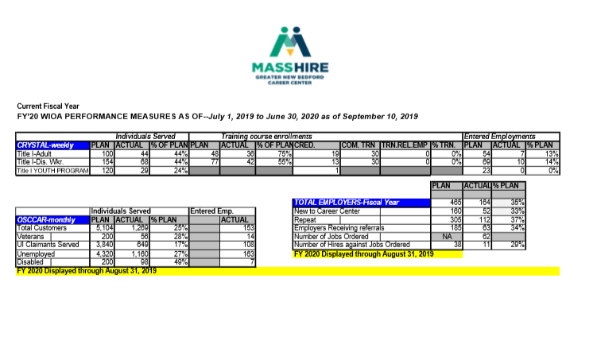

Career Center Performance Dashboards

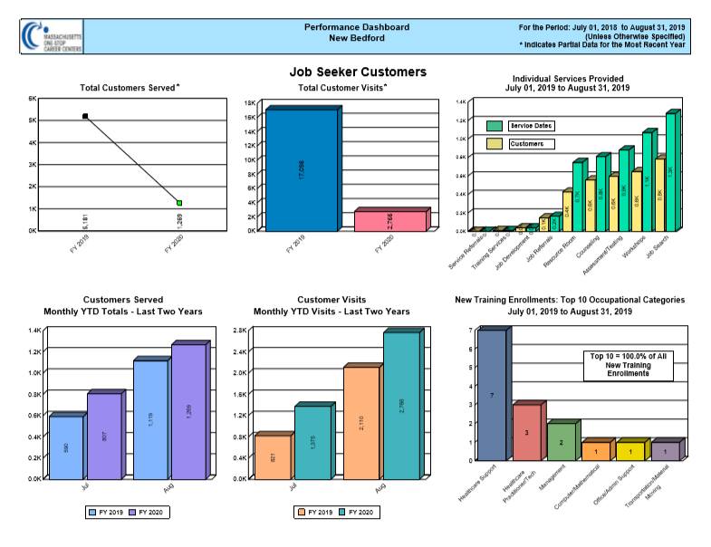

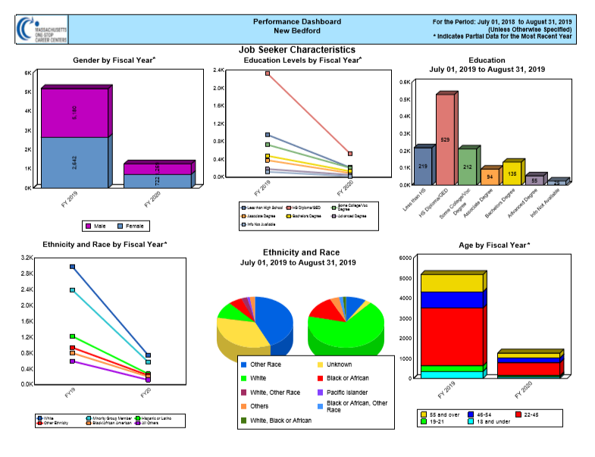

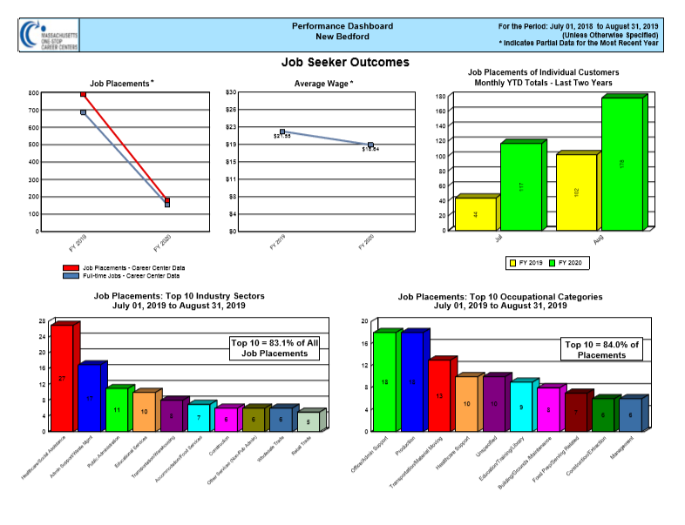

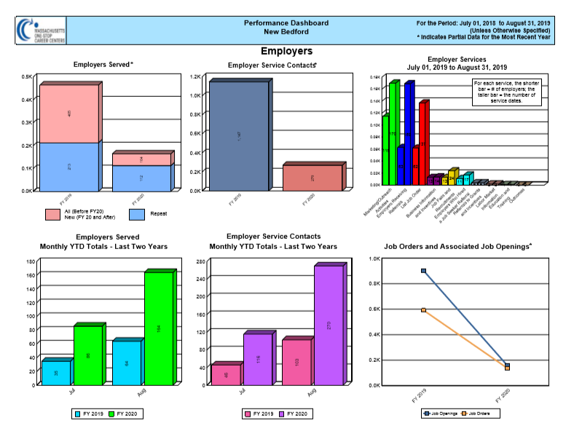

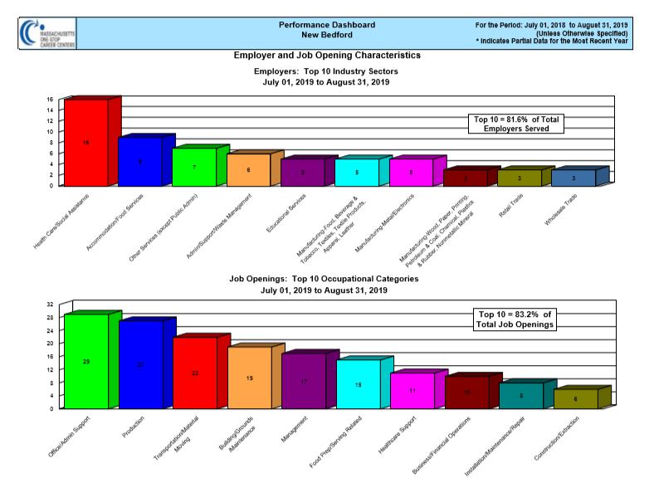

TEACHER EXTERNSHIP GUEST SPEAKER - ISAIAH HOUTMAN

Overview – The Connecting Activities funding opportunity for Workforce Development Boards was designed to support the development of Teacher Externships in industries suffering from skill gaps recently identified via the Regional Blueprint process. The intended externships will enable high school teachers working in Perkins programs to gain knowledge of contemporary practices in businesses operating in those industries and will equip the teachers to develop new contextualized lessons for their classes relating to the issues they learn about while on site. The teachers will also be able to support student career awareness about, and encourage student interest in, these industries and organizations.
Please join us in welcoming Isaiah to the Board of Director’s meeting. Let’s listen as he shares his experiences in the teacher externship program and more importantly how he has been able to help students learn more about our priority and emerging industries and the Career Pathways associated to those industries.
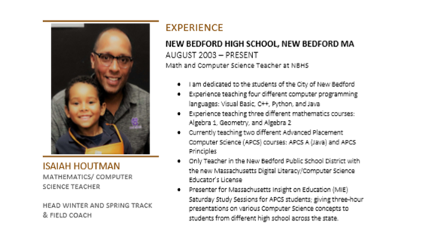

FY20 MEETING SCHEDULE

Meetings are subject to change and posted on our website at https://masshiregreaternewbedford.com Please click on the Meetings and Events tab for details. Save-the-dates and invites will be sent electronically by Deborah Meggison.
Board of Directors Quarterly Meeting schedule for the remaining year into 2020
- Thursday December 12, 2019 Venue TBD – suggestions
- Thursday March 2020 TBD
- Thursday June 2020 TBD

ADJOURN

