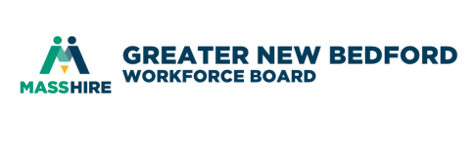
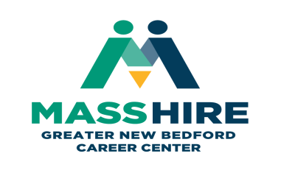

MOU Development Core Partner Meeting #18
September 27, 2019 9:30 – 11:00 am
MassHire Greater New Bedford Career Center – Scrimshaw Room (south side corner of building)

TIME | AGENDA ITEM | FACILITATOR | PURPOSE | ESSENTIAL ITEMS FOR DISCUSSION
9:30 | Welcome & Agenda Review | J. Oliveira | Introductions  and Minutes | New member and guests.  Distribute 7/19/2019 minutes.
9:40 | Customer Intake Form | All | Follow-up | Would anyone like to share how is the process going for them?
9:55 | Career Pathways (CP) | D. J. Ramos/  J. Oliveira | Open discussion and updates | WDB staff had conversations with The Workplace on how we need them to move forward with more Career Pathways training for staff. End result, Ashley Vandiver will deliver training at the professional development today Friday September 27th. They will provide us with a Professional Development sign in sheet.
10:15 | Rosetta Stone | All | Follow-up | Does anyone have any updates to share relative to the information that Mitch shared with all of us.
10:25 | GED/HiSET/ESOL | All | Follow-up | Has anyone been able to make any connections? Looking to support the Dislocated Worker populations with expansion ideas through summer months so that it is year-round.
10:30 | WIOA Populations with Barriers and Proposed Solutions | D. J. Ramos/  J. Oliveira | Sharing ideas and solutions | This is a Washington document to use as a tool that works within our State Plan. These solutions are viable and may provide us with solutions that we would have not thought about. http://www.wtb.wa.gov/Documents/WIOABARRIERPOPULATIONchart.pdf
10:55 | Next meeting date | D. Meggison | Next meeting suggested dates | Friday November 22 @ MassHire GNB Career Center
11:00 | Thank-you & Adjourn | J. Oliveira

