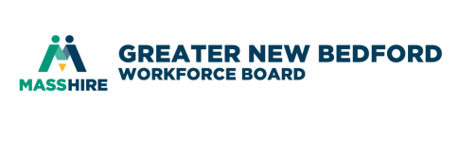
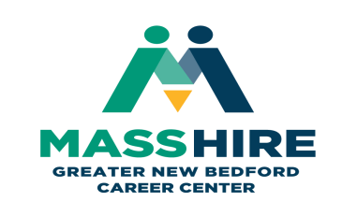

MOU Development Core Partner Meeting #17
July 19, 2019 9:30 – 11:00 am
MassHire Greater New Bedford Career Center – Scrimshaw Room (south side corner of building)
TIME | AGENDA ITEM | FACILITATOR | PURPOSE | ESSENTIAL ITEMS FOR DISCUSSION
9:30 | Welcome & Agenda Review | J. Oliveira | Introductions  and Minutes | What would you like to get out of today’s meeting?  Distribute 5/31/2019 minutes.
9:40 | Customer Intake Form | B. Costa | Usage | Brief update on how is the process going
9:45 | Career Pathways (CP) | All | Open discussion | - WDB to share different CP materials  - How does CP work within the boundaries of the Career Center  - How does CP work with our Partners considering the shared customers  - How can the academia assist us with CP? Are there charts available (priority industry sectors) to start that can be shared for the counselors ton use both from the CC and Partner Agencies?
10:45 | Rosetta Stone | All | Open discussion | Any updates
10:50 | GED/HiSET/ESOL | All | Update | Has anyone been able to make any connections? Looking to support the Dislocated Worker populations. Expansion ideas through summer months
10:55 | Next meeting date | D. Meggison | Next meeting suggested dates | Friday September 27 @ MassHire GNB Career Center  Friday November 22 @ MassHire GNB Career Center
11:00 | Thank-you & Adjourn | J. Oliveira

