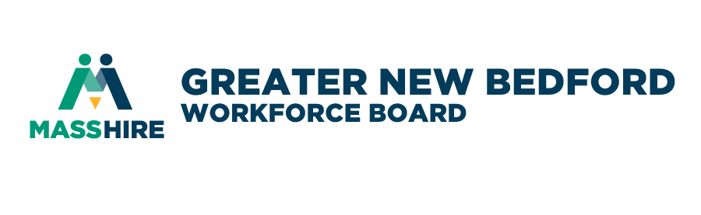

MassHire Greater New Bedford Workforce Board
Agenda Annual Meeting
Thursday, June 20, 2019

GREETING AND CALL TO ORDER

INTRODUCTIONS AND ANNOUNCEMENTS Dave Slutz, Chair

CONSENT AGENDA Dave Slutz, Chair
- Minutes of April 2019 Quarterly Meeting - Pages 4-10 (Vote required)
- Treasurer’s Report (Vote required) Julie Rodriques, CFO

EXECUTIVE DIRECTOR REPORT Jim Oliveira, ED/CEO
FY17 – FY19 WIOA LOCAL PLAN (ppt)

ELECTION OF FY20 OFFICERS Rick Kidder, Nominating Chair

REPORTS
- Business Development Committee – Vote required Rick Kidder, Chair
- Performance & Oversight Committee Ron Melbourne, Chair
- Youth Council – Vote required Jeff Pelletier, Chair

GUEST SPEAKER The WorkPlace

BUSINESS
- THE WORK PLACE CHARTER EXTENSION–Vote required Dave Slutz, Chair
- PTO REVISION TO THE MASSHIRE WORKFORCE BOARD
EMPLOYEE MANUAL – Vote required
- PAID FAMILY & MEDICAL LEAVE LAW (PFML) PASSED – Vote required

CAREER CENTER OPERATIONS James Daniels, Director of the MassHire Career Center
ADJOURN

