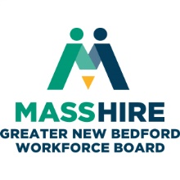
MassHire Greater New Bedford Workforce Board

Executive Committee
Tuesday, March 26, 2019 @ 12:00pm (lunch available)
Quest Center 2nd floor conference room (large room in middle of the floor)

AGENDA

- Greetings and Call to Order

- Announcements
  - New staff member – Deborah Meggison Program Manager, Manufacturing & Healthcare and Human Resource Specialist
  - Reminder - State of the City @ New Bedford Public School - Thursday March 28

- Consent Agenda (Vote)
  - Minutes of January
  - Treasurer’s Report

- Reports
  - Executive Director
    - MWA Newsletter
  - Business Development
  - Youth Committee
    - Out-of- School Youth contract amendments
      - Groundworks (Vote)
      - Eworkstyle (Vote)
- Board appointments

- FY20 Nomination Committee

- Other Business – EOHED Manufacturing Strategic Plan for the Southeast Region PPT handout
  - Manufacturing training update – Deborah Meggison
    - Cohorts underway
    - Cohorts planned
  - Manufacturing planning – Donna update
    - Process
    - Requirements

- Board of Directors meeting reminder scheduled for April 2, 2019 at New Bedford Harbor Hotel

Adjourn

